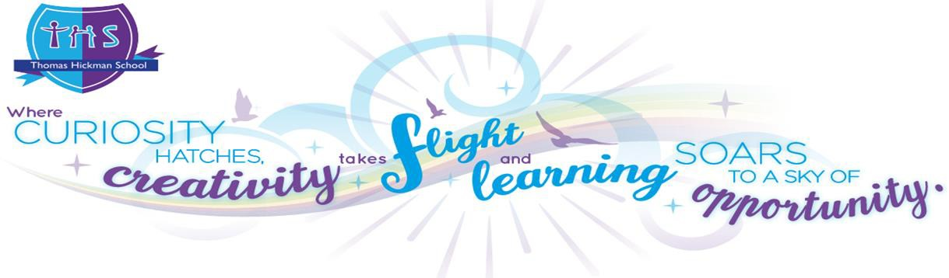

Equalities Report March 2026

Equalities Objectives

In accordance with our statutory public sector equalities duties Thomas Hickman School has adopted the following equalities objectives for the period 2026 – 2029. We agree to:

- Continue to develop policies and practices to further eliminate both conscious and unconscious discrimination, harassment and victimisation and, in particular, react to new challenges when they arise.
- Promote equality of esteem, access and opportunity within our school and within our wider community.
- Promote and maintain positive attitudes to difference and diversity.
- Continue to promote and embed the good relationships and understanding between people with different backgrounds, genders, cultures, faiths, abilities and ethnic origins.

Legislative Framework
This document meets the requirements under the following legislation and guidance:
- The Equality Act 2010, which introduced the public sector equality duty (PSED) and protects people from discrimination. Under the general duty, schools must have due regard to the need to: (1) eliminate discrimination and other conduct prohibited by the Act; (2) advance equality of opportunity between people who share a protected characteristic and those who do not; and (3) foster good relations across all protected characteristics.
- The Equality Act 2010 (Specific Duties) Regulations 2011, which require schools to publish information to demonstrate how they are complying with the public sector equality duty and to publish equality objectives at least every four years.
- The Equality Act 2010 and schools – non-statutory advice from the Department for Education (DfE), which informs the approach set out in this document.
The protected characteristics covered by the Equality Act 2010 are: age, disability, gender reassignment, marriage and civil partnership (employment only), pregnancy and maternity, race, religion or belief, sex, and sexual orientation. This statement addresses all relevant protected characteristics as they apply to pupils, staff and other members of our school community.

The governing body is responsible for ensuring that this school complies with the public sector equality duty. The headteacher is responsible for implementing the equality policy, ensuring that all staff are aware of their responsibilities, and for taking appropriate action in any cases of unlawful discrimination. This statement will be reviewed and updated at least every four years, in line with statutory requirements.

How we do this

All learners – child, staff member, governor, parent/carer - at Thomas Hickman School are BIRDS which stands for Brave, Inspirational, Respectful, Determined and Scholarly.

Our BIRDS values are central to everything we do and are explained in more detail below. We all strive to demonstrate them in and out of school, at all times, in all that we do.

We are also a NO OUTSIDERS school – There are ‘No Outsiders’ at Thomas Hickman School because everyone is included: everyone is welcome and all difference is celebrated.

At THS we endeavour to improve the lives of all our children, young people and families whatever their circumstances. We celebrate all our children and their families without discrimination, and take steps to tackle all kinds of bullying. In doing so, we believe that children will achieve more at school and our community will be happier and more successful.

We are a caring community where our whole-school, BIRDS charter is built on mutual trust and respect for all, regardless of race, religion, ethnicity, sexual orientation, gender identity, disability, age or gender. The ‘No Outsiders Here’ message fulfils our duty to promote diversity and prepares our children for life in modern Britain.

B.I.R.D.S School Values
The BIRDS values underpin everything that we do at Thomas Hickman School and apply to all members of our school community.
Brave We face challenges with strength and are willing to ‘have a go’ and
take risks.
Inspirational We are inspirational citizens and there is no limit to what we can
achieve for ourselves and our community.
Respectful We respect everyone as individuals regardless of differences and do
the right thing even when no one is watching.
Determined We are determined to succeed and strive for greatness, even when giving up is the easier option.
Scholarly We gain knowledge by being curious; empowering us to create the lives we want for ourselves. We call this ‘growing our brains’.

‘No Outsiders Here’ is underpinned by British Law and supports the Equality Act 2010 to ensure that everybody is treated equally and without prejudice.
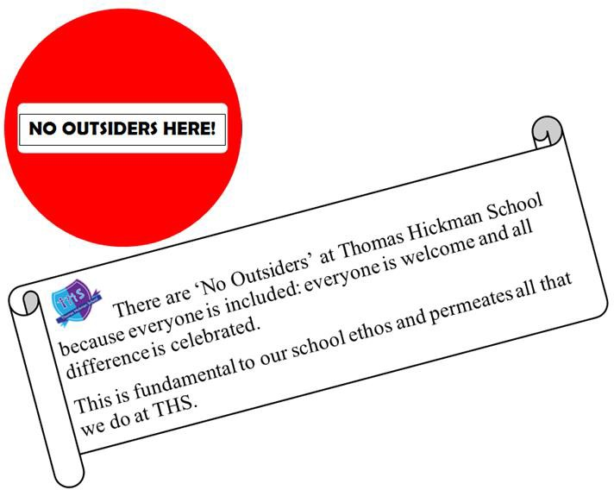
At Thomas Hickman School we endeavor to improve the lives of children, young people and families. We celebrate our rich diversity and take steps to tackle all kinds of bullying. In doing so, we believe that children will attain more at school and our community will be happier and more successful.
We celebrate all our children and their families without discrimination.
We are a caring community where our whole-school, BIRDS charter is built on mutual trust and respect for all, regardless of race, religion, ethnicity, sexual orientation, gender identity, disability, age or gender. The ‘No Outsiders’ message fulfills our duty to promote diversity and prepares our children for life in modern Britain.
‘No Outsiders’ is British Law and supports the Equality Act to ensure that everybody is treated equally and without prejudice.

At Thomas Hickman School we are determined that all our students will achieve the best that they can academically. However, this equality is about much more than academic achievement and it is key to our approach. We are committed to ensuring that all pupils have as full access as is reasonably practical to all the opportunities that the school provides and that all students, regardless of

background, gender, culture, faith, ability, economic status or ethnic origin will be treated with equal respect by fellow pupils, teachers and other employees.

Our school has specific policies on Admissions, Behaviour, Bullying, Equalities and Special Educational Needs. We also have an Accessibility Plan to ensure that children and staff who have disabilities have access to the full range of the school’s activities in an equitable way and that adaptions are made if a new person joins our community and our existing provision does not fully meet their needs. We ensure that all policies, but especially these policies listed above, promote all forms of equality. Policies are regularly reviewed and agreed by the school’s Governors and they form a key part of the basis of the day to day running of our school. We also keep data on pupil performance under regular review so that we can identify any groups of children that appear to be underperforming, analyse the reasons why and take steps to remove any barriers to learning.

In addition to doing whatever is reasonably practical to meet the specific needs of children who have a disability, Special Educational Need, a medical condition or who qualify for Pupil Premium funding, we endeavour to ensure that they do not miss out on wider curriculum activities, such as school trips, Field of Study Wow days or opportunities to attend a THS Club – on average, we have over 25 different clubs each week on offer. Adaptations and accessibility strategies are offered where possible.

Behaviour and Relationship Policy and Principles: Hand on Heart
As a Trauma Informed School (TIS) staff at Thomas Hickman understand that Adverse Childhood Experiences (ACEs) will impact a child’s ability to manage school life and inhibit their ability to learn and reach their ambitions. Our Behaviour and Relationship Policy is called ‘Hand on Heart’ and works in in synch with our commitment to equality and diversity. It intersects with all the following areas;

Pupil Premium

We take specific measures to improve the performance of Pupil Premium children. These are covered by a separate report on our use of Pupil Premium money.

Disability

Thomas Hickman School has a commitment to support children with disabilities.
We will make all reasonably practical adaptations to our school on a needs basis to enable all children to participate equally. For example, for a child who accesses school in a specially adapted pram, we have ramps to access all school areas. We also provide specially adapted furniture, i.e. a special desks/chairs/equipment which allows students to work together, as one.

We recognise that disability can also have a negative effect on siblings. For example, they may feel left out at home because the child with the disability gets more parental attention. We look out for such siblings and they too can get one to one support from our Acorn (Pastoral) team.

English as an Additional Language

English as an Additional Language has always been important at Thomas Hickman School, with approximately 44% of the school having an additional language. Historically, our EAL pupils achieve well in national assessments and continue to learn well at THS but we are conscious that these children may have particular challenges with accessing the curriculum when new to the school and are alert to

the need to tackle that should it arise. We have a few members of staff who regularly translate for parents who require support in reading newsletters and accessing school meetings.

Special Educational Needs

This term covers a multitude of conditions with different symptoms and effects on learning. Even within a single definition, the consequences will be on a spectrum from mild to severe. Thus, each child with a SEN needs to be supported in a different way as best fits their circumstances.

A key element of our Hand on Heart policy is analysing the cause of behaviour issues. There are many differing reasons why children struggle to meet the school’s behaviour standards and discovering those reasons may be the first clue leading to the diagnosis of a Special Educational Need. It is certainly an essential precursor to tackling those behaviour issues successfully.

As with children who are disabled, we make any reasonably practical adjustments that will help tackle the issues faced by any particular child. We have interventions such as ‘Aviary’ in place, to support children at playtimes who find these undirected opportunities challenging, ‘Welly Warriors’ ‘Tree Tops’ an SEMH intervention for KS1 children who find the classroom environment over-stimulating and over-whelming. ‘W1nders/Twocans’ for children with complex needs who need a space to learn which meet their needs.

Some children have a Positive Intervention Plan (PIP) to ensure consistency and to support their development of better routines and behaviours. These plans are written in conjunction with the Inclusion Lead, Class Teachers, Co-DHT and Assistant Teachers. Parents are also involved in this process and are encouraged to adopt and adapt for home use where appropriate.

We have, in the past, and still regularly negotiate outreach arrangements with the local PRU (Pupil Referral Unit). The school are trained in the Norfolk Steps approach and apply these strategies to our the behaviour provision. We also work with a range of external alternative provisions to enable all children, whatever their need, to access their right to education.

One situation that can be particularly difficult for children with SEN is transition – moving from one setting to another. The biggest hurdle is from Primary to Secondary but pre-school to Reception, Reception to main school and even moving to a new year group can be a challenge.

We produce personalised transition plans for students moving to secondary school. Whilst every school will have its own policies for supporting SEN pupils, this approach ensures that all the relevant information that we have about how that individual best accesses the curriculum and what makes them feel happy and safe in school is passed to their new location. We will arrange a pre-visit for children joining us and will seek (usually successfully) to arrange such a visit for a student leaving us. This means that, when they start at their new school, it is not totally strange to them. This limited familiarisation can be a great benefit. Something that formal is not appropriate when moving within the school but we apply the same principles to internal moves. If it will make life easier for the child and it is reasonably practical, we will do it.

Children with Specific Medical Needs

There are many children in our school who are not registered as disabled but who have conditions that may affect their access to education or even their safety – such as Asthma, Epilepsy, Anaphylaxis. Similarly, although Diabetes qualifies as a disability, many sufferers do not consider it as such. All staff members are routinely trained in these areas.

It is not possible, in a school our size, for every member of staff to know the circumstances of every child who has a medical condition. However, we ensure that staff who are in regular contact with the child concerned (typically the class teacher and Assistants teachers) have detailed knowledge of the condition, have accessed any relevant professional training and know what to do if an incident occurs. With life threatening conditions, such as nut allergies, we ensure that there is a much wider knowledge of the children suffering from that issue so that urgent action can be taken to ensure safety. We have a policy called Allergens at School. This covers these issues and ensures that all relevant adults have the information that they need.

Core to this, and to improving children’s ability to gain the full benefit from the opportunities at Thomas Hickman, we employ a full-time medical officer who coordinates meeting the needs of those children with specific medial needs – this role is also a DSL and part of the Pastoral Team. This post is in place because we recognise that teaching staff are not and cannot be medically trained and that, as a relatively large school, it is not practical to provide specialist training on all the individual conditions that we see.

Our Medical Officer is a source of advice and support to staff and parents who have responsibility for affected children on a day to day basis. They are trained to make judgements as to whether a situation can be managed in school or requires action by a medical professional outside school. They also provide direct support to children as someone to whom they can talk in confidence if they need support or advice from someone who understands their situation.

Where needed the Medical Officer liaises directly with the school nurse and consultants to ensure training is specific for the child to ensure they have access to mainstream school. Care plan are regularly reviewed and updated.

Racism, Personal, Social and Health Education (PSHE), Social, Moral, Spiritual and Cultural Education (SMSC) and related wider issues

Our PSHE programme covers both SMSC and the No Outsiders Here initiative and includes teaching the understanding of, and respect for, British Values together with respect and understanding for all religions and moral codes. We have a zero tolerance policy towards religious prejudice or disrespect of religious beliefs.

We have the same approach towards Race, Nationality, and Homophobia. We seek to inform our pupils about British culture but also that of other nations. Racism and racist incidents are wholly unacceptable, as are any discriminatory remarks.

The school are involved with the “Show Racism the Red Card” initiative.

We recognise that young children can say or repeat things which cause offense and upset without understanding how or why. We are committed to teaching diversity and inclusion throughout the all year groups in a meaningful and constructive way which enables children to learn how to respect communities whose lives they touch.

The school’s response to managing any discriminatory incident will be full, fair and thorough. Whilst it will be informed by context and intent, any discriminatory remark whether malicious or innocuous is unacceptable. We use our CPOMS system to monitor this which supports the comprehensive recording for such matters, including the outcome.

The school will take the action necessary to prevent repetition. There has been between 0-5 incidents last academic year (2024-2025) involving discriminatory name calling.

Anti-Bullying
Section 89 of the Education and Inspections Act 2006 states that maintained schools must have measures to encourage good behaviour and prevent all forms of bullying amongst pupils. THS record incidences of bullying and considers every bullying incident is an opportunity to learn and to improve our shared approach to tackling bullying

Bullying can be fuelled by prejudice, at THS we work to create a culture where prejudice and hatred is not accepted: our key phrase is ‘No BIRD’s a bully’ which also works with our our No Outsiders principles. Behaviour which is homophobic, transphobic, racist, targeted at faith, sexist and disablist is tackled head-on.

Children who are being bullied or are in fear of bullying cannot emotionally thrive or learn effectively. Bullying is not simply a 'falling out'. Research shows that experiencing any form of bullying can have a significant impact on a child's life well into adulthood. To ensure we are able to prevent bullying, act quickly when it takes place and avoid misidentifying bullying, we have a clear, shared definition of bullying via our Hand on Heart Policy. Action taken will always depend on circumstances but bullying, whether physical, verbal or psychological will be tackled firmly and fairly. The children, and parents/carers of the child involve, will be left in no doubt as to the school’s position on this matter. We have invited the NSPCC into school to run assemblies to all children in the school. We also commission ‘My Future Self’ an organisation which works with children in Upper KS2 of whom are identified as vulnerable in the community and at risk of either being a bully or being bullied.

The school invests in the Peer Mentor programme.

RSE
Through our PSHE programme (see separate policy) we sensitively provide age-appropriate information and opportunities for support and discussion for children at the top end of the school about growing up and the changes that will affect them. We have consulted with parents/carers in relation to the statutory RSE curriculum and their views have influenced our program content. The PSHE curriculum is designed to help them feel comfortable about the changes that may occur whilst they are still at Thomas Hickman School and to ensure that they are able to give their best without worrying about such matters. The dates of these lessons are always shared with parents in advance.

Pastoral Support

Our Pastoral/DSL Team support families with a wide range of concerns from toileting and sleep issues to challenging behaviour and safeguarding issues. All this happens within a designated space on the school site which includes a family room, therapy room and large group work space. This ensures that we can support all of our families effectively regardless of their circumstances or need.

Our DSL team work closely with external professionals (Social Care, Virtual Schools and Early Help and Family Support) to ensure that all children are safe and supported appropriately at school. Our Co-Deputy Head is designated to support LAC and previously LAC children and liaises with parents and the Virtual Schools Team.

Our Co-Deputy Head, is a qualified Child Therapist and provides 1:1 and group therapy. She is also delivers Hand on Heart@Home courses which are our own, bespoke parenting program supporting THS parents/carers in managing behaviour and relationships in the home. We have 2 PAFT workers in EYFS strategies are also used to support families, particularly those with younger children.

