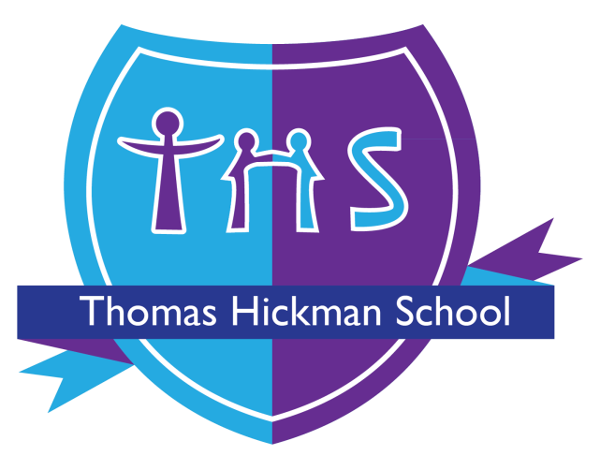

Thomas Hickman School
Uniform Policy
Adopted by the Governing Board Meeting: October 2024
Governing committee accountable for review: FGB
Date of last review: September 2026
Date of next review: September 2027

Uniform
At Thomas Hickman School our aim is that all children are dressed appropriately and ready for lessons every day. We feel it is of vital importance that each child is dressed in a smart and clean uniform. This helps to form a sense of belonging and promotes positive self-esteem.
The co-operation of parents is appreciated to ensure that each child is provided with, and wears, our uniform at all times.
The Governing Board recognises that school uniform should be affordable, practical, inclusive and accessible. The school will have regard to the Department for Education statutory guidance on the cost of school uniforms and will seek to ensure that the cost of uniform and PE kit is not a barrier to attendance or participation.
The school will keep compulsory branded items to the statutory limit. From 1 September 2026, as a primary school, Thomas Hickman School will not require pupils to have more than three compulsory branded items of school uniform and PE kit across the school year. Generic, widely available alternatives will be used wherever possible.
Where an item is branded, the school will identify this clearly and will consider whether a generic alternative is acceptable. The school will avoid unnecessary changes to uniform specifications and will consider the impact of any change on families, including the ability to reuse or pass items on to siblings.

Details of our uniform are as follows:

Nursery to Year 6
- Navy Thomas Hickman sweatshirt or cardigan (V Neck sweatshirt for year 6)
- Black or grey trousers / skirt / pinafore dress
- White buttoned shirt / white blouse
- White Hijab or headscarf (optional)
- Black / grey / white trousers under a skirt, dress or tunic are optional for religious requirements
- Black shoes (No sandals. No heels. No trainers. No boots)
- White, grey or black socks / grey or black tights
The Thomas Hickman sweatshirt/cardigan is the school's compulsory branded item. The school will continue to monitor the number of compulsory branded items required so that the statutory maximum is not exceeded.

Optional for Muddy Ducks Nursery and Pre-School ONLY
- White polo shirt
- Grey/black jogging trousers while children are toilet training

Optional Summer Uniform
- Black or grey knee length shorts
- Blue and white checked dress

PE Kit (Reception to Year 6)
- House colour t-shirt (yellow, red, blue or green)
- Black shorts or leggings / jogging bottoms
- Plimsolls or trainers
- Plain black jumper
- Socks
From September 2026, children in Reception to Year 6 will be asked to come into school wearing the specified PE kit on their PE days. This is intended to support efficient use of curriculum time and reduce disruption associated with changing. Parents/carers will be given the PE days for their child in advance.
The specified PE kit will be kept simple, practical and affordable. The school will not require unnecessary additional PE clothing for different sports or activities. No pupil will be prevented from participating in PE because they cannot afford the required kit; parents/carers should contact the school confidentially if support is needed.
The PE kit listed above is generic unless expressly identified otherwise. The school will not require a branded PE item where a suitable generic alternative is available, and any compulsory branded PE item will count towards the statutory limit of three compulsory branded items for primary pupils.

Affordability and access to uniform
The school will give high priority to affordability and value for money when reviewing uniform requirements and when arranging uniform supply. Parents/carers will not be required to purchase uniform from a single supplier unless there is a clear and proportionate reason for doing so.
Where possible, generic items that meet the school's stated specification may be purchased from a range of retailers. The school will provide clear information to parents/carers about which items are compulsory, which are optional, which items are branded and where they can be obtained.
The school will make second-hand uniform available to families and will publish information on the school's website about how second-hand uniform can be accessed. Access to second-hand uniform will be freely available and will not depend on attending or paying to attend a school event.
Families who are experiencing financial difficulty or who cannot afford uniform or PE kit are encouraged to contact the Headteacher or school office confidentially so that the school can consider what support is available.

Uniform compliance
Should children arrive at School not following the Uniform Policy then parents will be contacted to rectify the situation. In exceptional circumstances minor issues will be considered by the Head once parents have communicated the problem with School. Children should not turn up to school without the relevant support from parents.
The school will take a supportive and proportionate approach where a pupil is unable to comply with the uniform requirements. Lack of, or inability to afford, the correct uniform or PE kit will not be treated as a reason to prevent a pupil from attending school or participating in learning or PE. The school will consider reasonable adjustments and individual circumstances, including disability, medical needs, religious requirements and other protected characteristics.
Any consequences for non-compliance with the uniform policy will be applied in accordance with the school's Behaviour and Relationships Policy and will be proportionate. The school will consider whether the reason for non-compliance is within the pupil's or family's control before applying any consequence.

Jewellery and accessories
Children are not permitted to wear any accessories to school.
Accessories and/or Jewellery are defined as any item worn around the neck, arm, wrist, ankle, ear, nose, hand or finger. For Health and Safety reasons only watches and Medic Alert bracelets may be worn but they are the responsibility of the child concerned. The school cannot accept responsibility for the loss or damage to personal belongings.
If a child is seen wearing accessories and/or jewellery they will be asked to remove it and it will be handed to parents at the end of the day.
Children with pierced ears may only wear one plain metal stud per ear.
Parents of pupils with pierced ears take responsibility for the loss of any earrings and for any damage they may cause to their child or another child. Pupils are expected to remove their own earrings for PE lessons as staff are not allowed to assist them. If they cannot remove their own earrings, they should not wear them to school on PE days.
Where a pupil cannot remove jewellery or another item for a medical, disability, religious or other protected-characteristic reason, the school will consider an appropriate reasonable adjustment and will balance inclusion with health and safety requirements.

Earrings
If a child wears inappropriate earrings then they will be asked to remove them. If they are not able to do this, we will contact parents to rectify the situation. Children can return to class once rectified.

Hair
Haircuts should be sensible and should not prohibit a child’s learning or sport participation
- Hair colours and fashion marks shaved into the hair are not permitted.
- For Health and Safety reasons we ask that long hair be tied back for all lesson especially PE lessons (this includes our children with Afro-hairstyles – see below)
- Any hair accessories should be simple, smart and in keeping with the Schools colours (blue, black, white, purple, grey).
If a child arrives at school with a hairstyle deemed inappropriate by the Headteacher, we will contact parents to rectify the situation.
Hairstyles worn because of cultural, family and social customs can be part of a pupil's ethnic origin and therefore fall under the protected characteristic of race. We support the ‘Halo Code’ initiative in school.
THS champions the right of staff and students to embrace all Afro-hairstyles. We acknowledge that Afro-textured hair is an important part of our Black staff and students’ racial, ethnic, cultural, and religious identities, and requires specific styling for hair health and maintenance.
We welcome Afro-textured hair worn in all styles including, but not limited to, afros, locs, twists, braids, cornrows, fades, hair straightened through the application of heat or chemicals, weaves, wigs, headscarves, and wraps.
At this school, we recognise and celebrate our staff and students’ identities. We are a community built on an ethos of equality and respect where hair texture and style have no bearing on anyone's ability to succeed.
The school will ensure that requirements relating to hair are applied consistently and do not discriminate on grounds of race, religion or belief, sex, disability or any other protected characteristic. Requirements will be based on legitimate educational, safety or practical considerations and will not prohibit culturally or religiously appropriate hairstyles.

Makeup and nail varnish
Makeup and nail varnish are not allowed.
If a child is seen wearing makeup or nail varnish then parents will be contacted to rectify the situation. Children can return to class once rectified.

Inclusive and unisex uniform
Our aim is for our school uniform to be inclusive and unisex.
The school will ensure that uniform requirements are inclusive and that pupils are not disadvantaged by the availability, design or cost of different uniform options. Where pupils have a disability, medical condition, sensory need or religious requirement, the school will consider reasonable adjustments in accordance with its legal duties.

Information for parents and review
This policy will be published on the school website and will be available to current and prospective parents/carers. The school will clearly identify which uniform items are compulsory and which are optional, including whether an item is branded or generic.
The Governing Board will review the policy regularly, with particular attention to affordability, the number of compulsory branded items, second-hand provision, equality and inclusion, and the practical operation of the PE kit requirements.
The school will consult parents and pupils where significant changes to uniform requirements are proposed and will consider their views when reviewing the policy.

