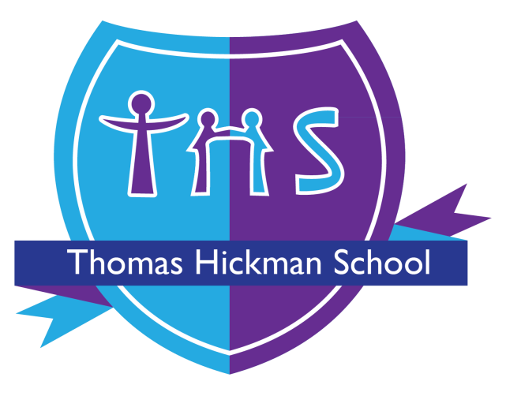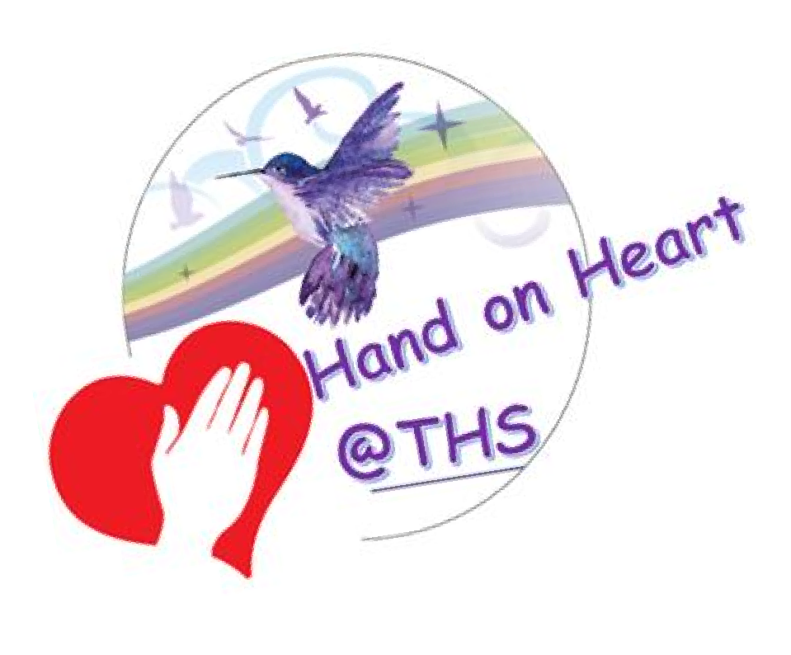
Thomas Hickman School

Behaviour and Relationship Policy

This policy was adopted by the Full Governing Board ……………………..
SLT Member Accountable for Review Co-Deputy Head Behaviour, Inclusion,
Pastoral and Safeguarding
Date of Last Review September 2026
Date of next review September 2027

Version | Summary of Changes | Date | Author(s)
Sept 25 | •
Jan 2026 | Addition of Emotion Coaching |  | AM







and stand up for what is right, even when no-one is

•

We will be

at Thomas Hickman and at all times we are expected to behave in a way in
keeping with our
BIRDS
philosophy.

looking. Everyone has the right to be safe and respected at THS.

- Our courage to do the right thing will  others around us to follow; we will be strong and lead the way. We will learn to be independent as we move through the school.

- We will be  to our THS school family. We will demonstrate this in class, at playtime and around the school. Our kind hands, kind words and kind heart will show people we all belong together: no BIRD flies alone. We will learn to build resilience as we grow and learn from our mistakes.

- Even when times are really hard, we will stay  to follow our school expectations.

- We ‘grow our brain’ every minute, of every day in all areas of school life:
we are  and understand that sometimes we need to learn how
to behave well too – we will accept reminders on how to do this and learn and listen to our adults and peers who support us in this.

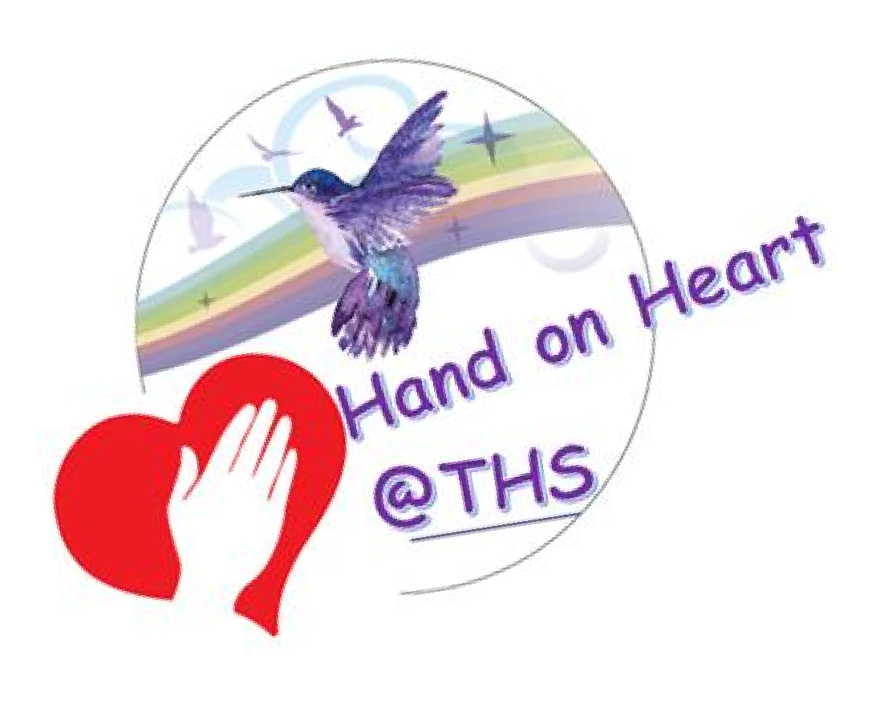

As a Trauma Informed School (TIS) staff at Thomas Hickman understand that Adverse Childhood Experiences (ACEs) will impact a child’s ability to manage school life and inhibit their ability to learn and reach their ambitions.

Research shows that children with 3 Aces or more are;
- Twice as likely to experience academic failure
- Five times as likely to have attendance problems
- Twice as likely to be overweight
- Thirty two times more likely to have behaviour problems

For every additional ACE there is an increased risk of learning difficulties, behaviour problems, obesity and mental health issues later in life.

Staff at THS know that emotionally available adults in school actually shape the neurocognitive development of executive functions in the child’s frontal lobe and therefore interrupt the impact of ACES – in essence, adults who have a strong relationship with a child can redirect a child’s future.

Therefore, staff work tirelessly to:
- Understand a child’s ‘story’ – what’s happened to them in their little lives so far, not ‘what’s wrong with them’?
- Develop secure attachments with the children in their care
- Ensure that children are kept safe, are seen and soothed and that they feel secure.
- Help children to understand how the 3 main areas of the brain work to support their emotional literacy, co-regulation and, ultimately, work towards self-regulation all of which are far more challenging for a child with ACES.

Hand on Heart underpins our approach to managing behaviour at THS.
It is a whole school approach that encompasses TIS alongside Norfolk Steps ‘Step-on’ methodology to ensure that our school community is a place where children are ready to be curious, take flight and learn well, leading to a sky of opportunity and a successful adult life.

The use of restrictive interventions is governed by the separate Thomas Hickman School Restrictive Interventions Policy. That policy must be read alongside this Behaviour and Relationship Policy and does not replace or override the school’s trauma-informed, relational and restorative approach.

Introduction
Our emphasis is on recognising and celebrating effort and success so that all pupils feel valued. We encourage pupils to take responsibility for their own actions and to understand the consequences and impact of their actions.

We promote the values of reflecting, restoring and repairing when dealing with any behaviour that deviates from our BIRDS flight path.

A therapeutic approach to behaviour is based on an understanding of a child’s development and responding to behaviour in a proportionate way taking into account the mental health of the child and understanding the reasons that result in such behaviour. This allows children to develop strong personal skills, together with the cognitive ability to understand how to solve a problem with growing independence. This is further developed through our ‘Hand On Heart’ approach.

Support for this approach comes from the DfE advice on “Mental Health and Behaviour in Schools” (2016) which states: “In order to help their pupils succeed, schools have a role to play in supporting them to be resilient and mentally healthy.” https://www.gov.uk/government/publications/mental-health-and-behaviour-inschools--2

Aims

1.1 Positive experiences create positive feelings and these will generate behaviours that are useful for the child and those affected by the child (prosocial behaviours)
1.2 At the centre of this is the importance of building positive relationships within the dynamic of the school- that includes all adults and children.
1.3 This creates an ‘inclusive school’ where behaviour is responded to consistently whether inside the classroom or not.
1.4 The policy provides a structured approach to expected behaviour in the school environment with clear expectations for each.
1.5 Staff response to behaviour issues is graduated and individualised- it takes account of mental health, other needs, vulnerabilities and unmet educational needs.
1.6 To build a community which values kindness, care, good humour, good temper, humility and empathy for others (BIRDS Charter).
1.7 To promote community cohesion through improved relationships (No Outsiders Here).

Relationship Overview

2.1 Increase in safety cues eg: meet and greet at school entrance
2.2 School staff trained in SPACE principles (Hughes 2015) playful, accepting, curious and empathic. Proven to shift children out of fight/flight or freeze positions. This has evolved at THS and we refer to SPACE – the S stands for ‘standard rule’: when we address behaviour incidents we ensure throughout the interaction that the children are reminded of the standard rules in school, this supports learning a better way.
2.3 Staff to ensure that interactions with children are socially engaging, not socially defensive, to decrease defensive response from children.
2.4 Whole school commitment to cease using harsh voices, shouting, criticisms and shaming, due to the proven negative impact on psychological well-being.
2.5 Implementing pedagogic interventions such as ‘I wish my teacher knew’ with individuals to enable children to feel safe to talk. And worry monsters in every classroom used consistently so that children can voice their worries.
2.6 Children to have the opportunity to forge secure attachments with emotionally available adults in school throughout their journey at THS.
2.7 Adjust expectations around vulnerable children to correspond with their developmental capabilities and experience of traumatic stress.
2.8 Nurturing the staff in such a way that they feel valued and emotionally regulated enough to interact with social engagement rather than defensiveness.
2.9 Staff to be provided ongoing training in relating to children in terms of the four key relational needs for secure attachment, which affect attunement, empathy, soothing and containment.
2.10 Whole school commitment to enabling children to see themselves positively rather than through a lens of threat, danger or self-blame.
2.11 Implementations designed to take a child from toxic stress to tolerable stress enabling them to feel soothed, secure, seen and safe.
2.12 Interventions with trained therapist to be provided to minimise and help repair the impact of emotional difficulties as a result of traumatic experiences.
2.13 Attending to the emotional regulating and well-being of staff to avoid burn out.
2.14 The provision of skills and resources to support parents and staff to have meaningful conversations with children who want to talk about their lives.
2.15 Children provided with the means to talk about painful life experiences within the context of an established and trusted relationship with a member of staff, such as school therapist.
2.16 PSHE informed by current research, supporting children in their development as young citizens (refer to school PSHE policy).
2.17 Training provided to help staff move children from ‘behaving’ traumatic/painful life experiences to ‘reflecting’ on those experiences to aid the development of coherent life narratives.

2.18 Staff provided training in Emotion Coaching.
- Recognising and Validating the emotion through empathic listening.
- Setting limits on behaviour and setting boundaries.
- Problem-solving with the child to support better choices in the future

Objectives

3.1 To ensure that all stakeholders work hard to develop strong relationships based on kindness and mutual understanding and where our differences are recognised and celebrated.
3.2 To give opportunities for children and adults to have restorative and reflective conversation in order to discuss the behaviour and wider impact and decide reparative next steps. This will usually involve all concerned parties, as appropriate, and may involve parents.
3.3 To give children and adults the opportunity to take part in reparative tasks and/or actions.
3.4 To record & report incidents of more serious behaviours as appropriate (racist, homophobic and bullying).
3.5 To take punitive action only when considered necessary (in line with Local Authority and National guidance).

Process – How do we manage behaviour on a daily basis? We SOAR or RESTORE

This is our soaring system, used to recognize when our BIRDS are truly capturing our values. A vast range of other positive recognition strategies are used across the school and throughout the day and include a smile, a well done, stickers and house points.

SOARING | What are we seeing? | What are we saying?
S1 | A child adopting bird values in all that they are doing, independently, even when no one is watching. | You are really soaring and standing out from the rest!
S2 | A child adopting bird values in all that they are doing, independently, even when no one is watching. And taking further flight. | You are flying high, you are rising above on your flight path. Let’s celebrate (class clap)
S3 | Fabulous learning behaviours. Living the birds values. | You are excelling! Other birds in the school should know about your effort. (Show and share). Class teacher will send home a postcard.
S4 | Excellent attitude to learning, with effort that is exceeding expectations in all areas. Modelling BIRD values and supporting others. | You really are soaring – a super BIRD, flying high. Tell other BIRDS about your efforts. Visit the Assistant Headteachers and share what you have been recognised for. They will make a call home and let your adults know what a brilliant bird you are.
S5 | Exceptional, stand out effort, achievement or action. Modelling BIRD values and supporting others. Encouraging others to follow on your flight path. | You are an outstanding leading bird, soaring high above. Visit the Deputy or Headteacher and share what you have been recognised for. They will make a call home and let your adults know what a brilliant bird you are.

Where restrictive intervention has been used, the Reflect/Restore/Repair approach will inform the post-incident debrief and review, alongside the statutory recording and reporting requirements in the Restrictive Interventions Policy.

Our restorative approach to behaviour ensures that children understand where things have gone wrong (reflect), develop strategies to change (restore) and find ways to make things better moving forwards (repair).

Reflect/Restore/ Repair | What we are seeing? | What are we saying? | Actions to support restoration or repair: the consequence
R1 | Finding it hard to follow expectations.  Examples:  Off task behaviour Inappropriate talking and/or disturbing others who are trying to learn. Connection seeking behaviour such as swinging on chair, calling out, impolite words and action. Repetitive noise making, tapping etc. Preventing others from concentrating. | I can see that you are finding this tricky, let me help you to reflect so that you can restore your behaviour. | Classteacher/TA to have a discreet conversation with the child to ensure they are aware of their work and expectations
R2 | Behaviour that is impacting others, BIRDS can’t learn. Examples: Repeated reminder of restoring behaviour reminded of in R1. | I can see that you are still finding it tricky, this means that  I will ask you to….. ( | Move to the hand on heart space in classroom, move to a different space in the classroom, have a 5 minute brain break etc).
R3 | Behaviour that is unsafe for themselves and others around them.  Examples;  Preventing the teacher from teaching.  Preventing BIRDS from  ‘growing their brains’. | You have not yet been able to restore and are ‘flying’ in the wrong direction. | Move to another class to allow class members to learn uninterrupted.  Classteacher to make a call home – explore triggers to dysregulation
R4 | A BIRD that is unable to be safe. Immediate change is needed.  Examples; Unkind words in or outside class. Unkind action in or out of class. | You will be working out class with (AHT). We will support you, but at the moment, you won’t be in your classroom. | Working with an AHT outside of classroom. Restore BIRD expectations before being able to return to class.
 | Behaviour not in-line with BIRDS philosophy.
R5 | Behaviour that significantly impacts others or themselves.  Examples’ Knowingly and deliberately working against school expectations:  - fighting  - bullying  - swearing  - damaging school property | You are not keeping yourself or others safe. You are being taken to……. | The consequences of an R5 include an internal exclusion or external suspension/ exclusion

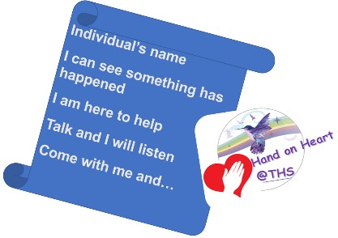
Our ‘Hand on Heart’ script ensures that all staff are consistent and this enables children to feel secure and to understand that they are being heard.

Further Clarification

4.1 For children with persistent behaviour concerns, it may be deemed appropriate to place the child on ‘report’. Further clarification of this process is available in the ‘Guide to being on ‘report’ at THS’ document which is attached as an appendix. Children may also be provided with a Positive Intervention Plan which details the triggers and threat responses of the child and the planned and consistent response from adults. All stakeholders will be involved in developing the PIP.
4.2 Our Pastoral Team provide our own bespoke Parenting workshop workshop entitled ‘Hand on Heart@home’, which also incorporates Triple P principles. Staff are also trained to deliver PAFT sessions to help support the behaviour of younger children at home.
4.3 For children with an identified SEND, reasonable adjustments will be made in line with the schools SEN Policy, Equalities and Cohesion Policy, SEN Annual Report and Equalities Report. We are committed to providing Alternative Provision where appropriate, as per Alternative and Offsite Provision Policy.
Where there is an identified or foreseeable risk of restrictive intervention, an appropriate risk assessment and Positive Intervention Plan/behaviour support plan will be developed or reviewed in accordance with the Restrictive Interventions Policy.
4.4 Physical intervention may be necessary where this is lawful, necessary and proportionate to prevent a child from causing injury to themselves or others, committing a criminal offence, damaging property or causing disorder among pupils at the school. This may include preventing a child from leaving the school premises where leaving would present a relevant and immediate safety risk, or moving a distressed child where this is necessary to reduce an immediate risk of harm. Any physical intervention will be undertaken in accordance with the school’s Restrictive Interventions Policy and the DfE guidance. Only appropriate methods will be used by identified trained staff, in line with Norfolk Steps / Step-on and the school’s trauma-informed approach.
4.5 Removal from a classroom under the R1–R5 Reflect/Restore/Repair process is not seclusion where the pupil is free to leave. If staff prevent a pupil from leaving a space, this may constitute seclusion or another restrictive intervention and must meet the requirements of the Restrictive Interventions Policy, including the requirements for necessity, proportionality, supervision, recording and reporting.
4.6 In the event of repeated poor behaviour, or a one-off instance of extreme behaviour which significantly contravenes school policy, the decision may be made to suspend a child from school (See Restore Rubrik) this may be for a fixed term. A decision will only usually be made after discussion with parents and children. We have adopted the Buckinghamshire Council Exclusion Guidance, August 2024. We follow the Suspension and Permanent Exclusion from maintained schools, academies and pupil referral units in England, including pupil movement
Guidance for maintained schools, academies, and pupil referral units in England September 2024
4.6 If the Head teacher suspends a pupil, they will inform the parents/carers immediately, giving reasons for the suspension. Parents and carers can make representations as per the letter of suspension to the governing body. The Head teacher will inform the LEA and the governing body about any suspension A fixed period suspension does not have to be for a continuous period.
4.7 If a pupil is suspended work will be set for the pupil to complete at home. Following a fixed term suspension, the pupil and parents/carers will meet with the Head teacher to discuss the pupil’s reintegration to school. If appropriate, an individual Positive Intervention Plan or a SEN Support Plan will be drawn up for the pupil.
4.8 At Thomas Hickman we believe that teachers have the right to teach and that children have the right to learn. If a child seriously breaches the school’s behaviour policy and if the pupil remaining in school would seriously harm the education and welfare of the pupil or others in the school, the Headteacher may take the decision to permanently exclude the child. This is the final sanction the school has available to deal with the most severe behaviour and this may be used as a result of all other interventions being applied and the pupil persisting in inappropriate behaviour.

Responsibilities

5.1 The Headteacher and Link Governor will be accountable for the practice relating to this policy and for the review of the practice and policy.
5.2 The Headteacher will record incidents of serious behaviour and report these, together with the action taken, to the Governing Body and outside agencies (as appropriate).
5.3 All adults will model positive behaviour, use appropriate strategies to support behaviour and resolve issues in a respectful way. They will record incidents and report these to their line manager & parents as appropriate.
5.4 Adults and children will acknowledge their behaviour, the effect of this on others and take steps to restore relationships.
5.5 Parents will model positive behaviour, will engage in discussions and will support the school in managing the behaviour of their child. This is also set out in the Home/School agreement.

- Anti-Bullying – No Outsiders Here!

We take a robust approach to dealing with any bullying by adults or pupils, with any such incidents dealt with promptly and firmly. There are ‘No Outsiders Here’ at THS (see below) all children and adults regardless of race, religion, ethnicity, sexual orientation, gender identity, disability, age or gender are respected.

Instances of racist, homophobic or bullying behaviour will be reported to the Headteacher and to external bodies as necessary.

Bullying is defined as the repetitive, intentional harming of one person or group by another person or group, where the relationship involves an imbalance of power. Bullying is therefore:
  - Deliberately hurtful
  - Repeated, often over a period of time
  - Difficult to defend against.
  - Bullying can fall into various categories i.e. Emotional. Physical. Racial. Sexual. Direct or indirect verbal. CyberBullying.

Further information on ‘No Outsiders Here’ principle
We have a rich and varied school community and we celebrate our differences and support each other so that no
BIRDS fly alone. We believe that there are No Outsiders Here at Thomas Hickman School…

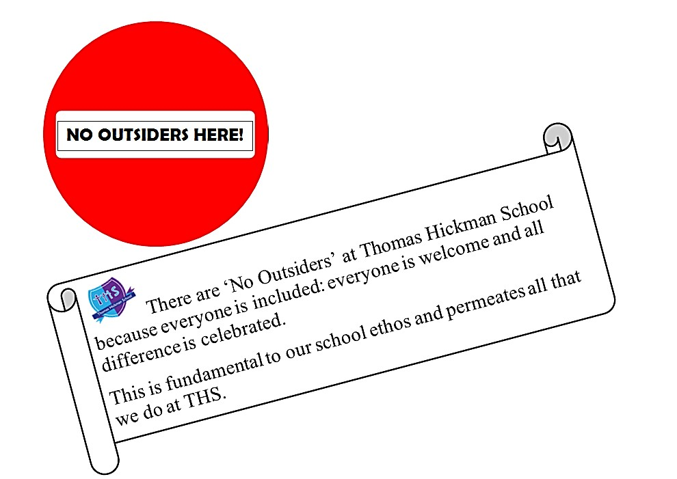

At Thomas Hickman School we endeavor to improve the lives of children, young people and families. We celebrate our rich diversity and take steps to tackle all kinds of bullying. In doing so, we believe that children will attain more at school and our community will be happier and more successful.
We celebrate all our children and their families without discrimination.
We are a caring community where our whole-school, BIRDS charter is built on mutual trust and respect for all, regardless of race, religion, ethnicity, sexual orientation, gender identity, disability, age or gender. The ‘No Outsiders’ message fulfills our duty to promote diversity and prepares our children for life in modern Britain.
‘No Outsiders’ is British Law and supports the Equality Act to ensure that everybody is treated equally and without prejudice.

Appendices

De-escalation scripts

Zones of Regulation

SPACE Model Language

Glossary of all terms relating to Trauma Informed approach

Threat Responses visual

Restorative Story Board

Guide to being on report at THS

Emotion Coaching

De-Escalation Scripts
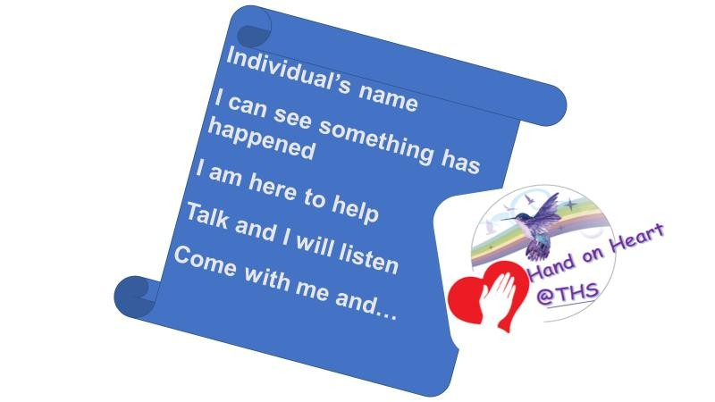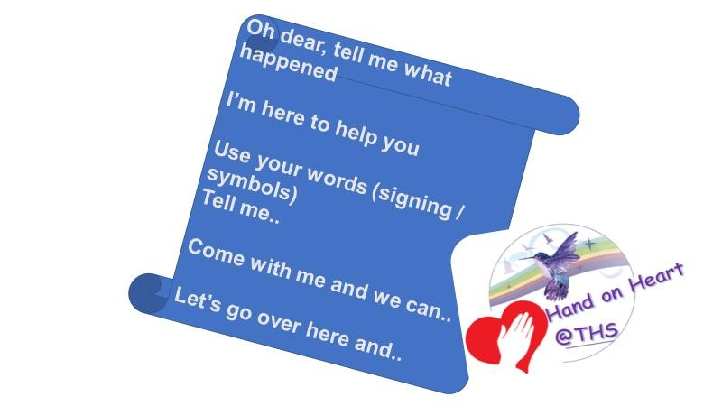

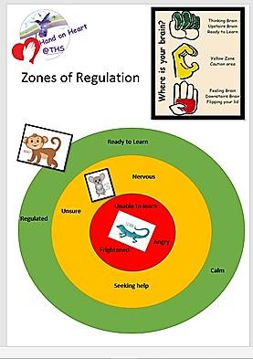

SPACE Model Language
Triggering language
Come back here NOW! STANDARD RULE
You are not allowed in there
You are beginning to annoy me Stop talking
We are all waiting for you
Don’t you dare… PLAYFULNESS
He/she is kicking off
He/she threw that for no reason
He/she is on one today He/she refused to…..
He/she chose to….. ACCEPTANCE

What we do instead – Model language

CURIOSITY
You can listen from there
We’re not here for spitting, you know that’s a standard rule,
perhaps you can tell me about those big feelings that led
you to spit? I could help. EMPATHY
Come back into the room when you are ready
That’s an interesting idea, thank you for sharing
I can hear that you are passionate about that but it’s a standard rule that we don’t swear. I can help you express your strong feelings in a more helpful way for everyone.
Ask for help if you need it, I am happy to help you
Come and sit here to take some time and I’ll be back for you soon
He/she is having a tricky time
He/she threw that, I wonder what might be happening for him/her. He/she is struggling and needs some extra care He/she responded by….
He/she struggled to……
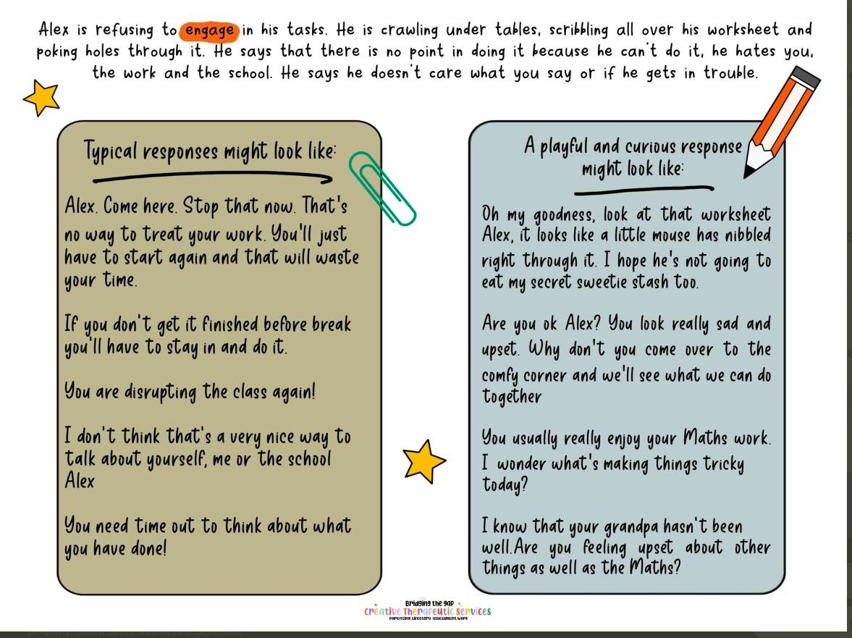
I wonder…. I imagine…
I notice…

Glossary of Terms for Hand on Heart @ THS
ACE
Amygdala
Attunement
Behaviour
Boundaries
Choices
Consequences
Consistency
Defences
Emotionally available adults
Empathy
Flight / Fright / Freeze
Grounding
Insecure Attachment
Language
Monkey / Mouse / Lizard
SPACE – Standard rule, playfulness, acceptance, curiosity, empathy
Power Threat Meaning
Protect
Relate
Repair
Restore
Regulating
Safe
Secure
Secure Attachment
Seeking systems
Seen
Soothe not swell
STEPS / STEP ON
Strengths
Threat response
Toxic Stress
Trauma
Trauma Informed
Zones of Regulation

Threat Responses – in children
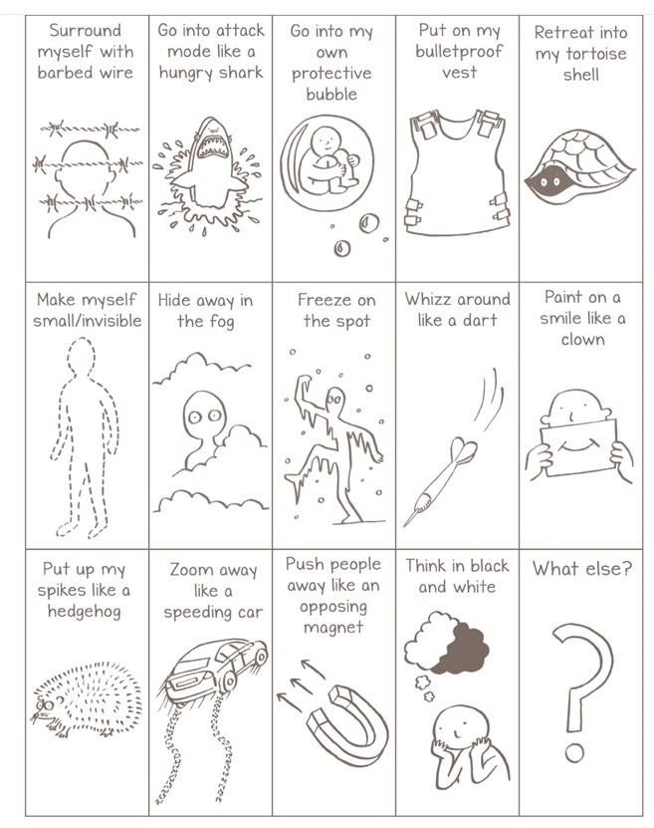

Organisation threat responses – in adults
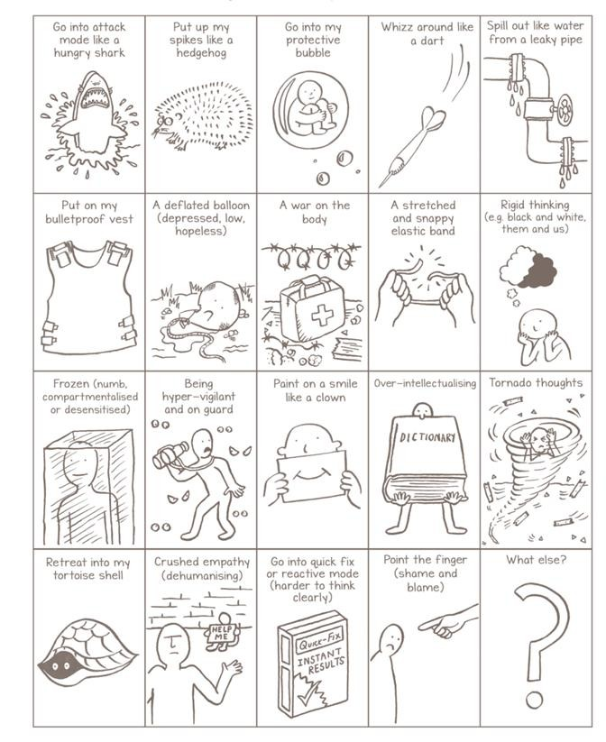

Restorative Story Board

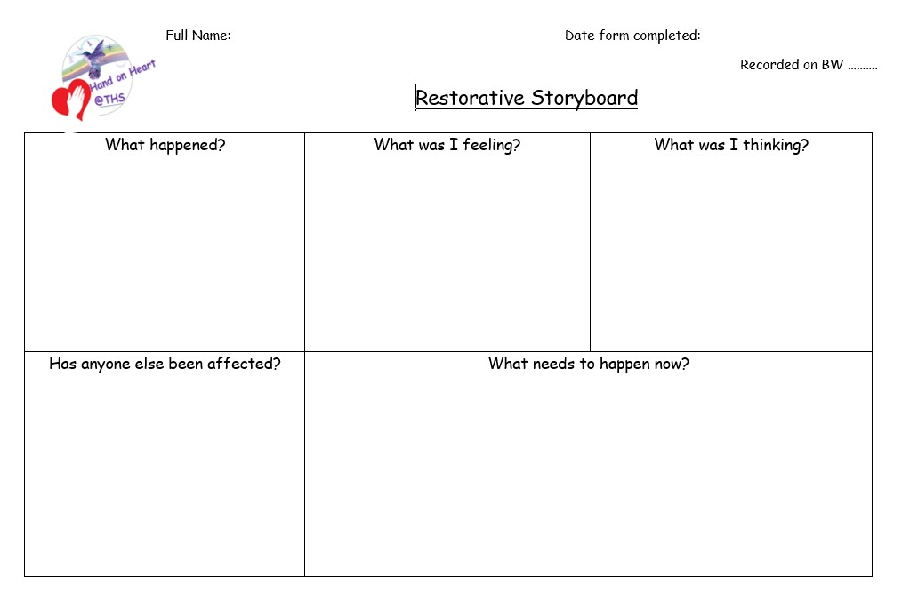


Guide to being ‘on Report’ at THS

The aim of putting a child ‘on report’ is to strengthen the work already being done by all stakeholders and to maintain the clear communication between home and school. It is only by working together that positive changes can be made to a child’s behaviour and, therefore, in the long-term improve their outcomes at school.

Placing a child ‘on report’ is a short-term reasonable adjustment to the school behaviour policy; a final layer to prompt positive change before further formal action may be required (as laid out in our behaviour policy). It is designed to sharpen the focus, provide additional support and guide those children who are persistently making poor choices in school and where further motivation is needed in order for them to make positive changes to their behaviour. The process provides children with additional praise when things go right; this in turn creates a more positive cycle. There is also the opportunity for children to discuss alternative options when things go wrong and what they could do next time. This process ensures that children are given the opportunity to restore their behaviour in line with the school behaviour policy, our BIRDS values and school expectations.

The decision to place a child ‘on report’ will be made between the class teacher and SLT and will involve looking at patterns of behaviour, what support and initiatives have already been put in place (e.g. behaviour charts, discussions with parents etc.) and the lack of progress with positive behaviour choices. Parents must also be part of this process and will already be aware of the increase in behaviour concerns through previous conversations with school staff.

If a child is put ‘on report’ then the following will happen:
- Parents will be contacted by a member of SLT and the process explained.
- The child will be given a report card.
- The child is responsible for looking after the card and for getting it completed – this is part of taking responsibility for their actions and being able to self-reflect.
- At the end of each lesson/break they will take the card to their teacher and decide with them whether a tick/happy face or a cross/sad face is needed and why.
- Each day a member of SLT will check the card, praise the achievements and discuss any issues.
- The class teacher or SLT will provide feedback to parents at regular intervals to update them with progress and discuss any ongoing issues.
- Children on report will no longer be able to walk themselves to or from school without an adult; this will be discussed with parents during the initial conversation (see point 1 above).
- After 2 weeks this process will be reviewed by staff and the child and parents will also be informed of how things are going. If there have been positive changes then it may be decided that the child can come off report. If there have still been some issues then the child will stay on report for a further week and then discussions will take place again.
- While on report the child will not be able to represent the school in any sporting teams or take part in additional/special events for specific groups of children.
- Children on report will still be able to take part in offsite visits, wow days and fabulous finales but these will need careful thought about how to support the child in order for this to be a positive experience. Risk assessments for offsite visits will need to be individualised to ensure the safety of all stakeholders.
- If being on report fails to have a positive impact then it may be necessary for further consequences to be put in place e.g. internal/external exclusion, exclusion from offsite visits. It may also be necessary to refer children to other external agencies for further support.
September 2020

Emotion Coaching as a Behaviour Support Tool
At THS we are committed to promoting positive relationships and emotional wellbeing as the foundation for behaviour and learning. In line with our nurturing ethos and evidence-informed practice, we use Emotion Coaching as a key strategy to support children’s emotional regulation and behaviour choices across the school day.
Emotion Coaching is an approach that helps children to understand and manage their emotions, particularly in times of heightened stress or behavioural challenge. Staff are trained to recognise emotional moments as opportunities for teaching and connection, using calm, empathetic communication to guide children through the process of self-regulation.
The core steps of Emotion Coaching include:
- Recognising and Validating the emotion through empathic listening.
- Setting limits on behaviour and setting boundaries.
- Problem-solving with the child to support better choices in the future.
This approach underpins our behaviour responses and complements our Hand on Heart approach to creating a safe, inclusive environment.
In addition to its use in school, we also incorporate Emotion Coaching into Hand on Heart at Home. This ensures consistency of language and strategy between home and school, supporting stronger parent–school partnerships and reinforcing children's emotional development in both settings.
The Education Endowment Foundation (EEF) identifies social and emotional learning (SEL) as having a positive impact on pupils’ academic outcomes and wellbeing. The EEF notes that programmes which integrate emotional understanding and regulation— such as Emotion Coaching—can lead to improved behaviour and engagement in learning.
"SEL interventions which focus on the development of self-awareness and self-regulation skills can support positive behaviour and academic attainment."
— Education Endowment Foundation, 2023
“Emotion Coaching (EC) is an approach that fosters teachers’ and early years staff’s warm and responsive relationships with children through self-regulation and co-regulation of both children and adults. EC supports children to understand the different emotions they experience, why they occur and how to handle them.” - Education Endowment Foundation 2024
Through Emotion Coaching, we aim to foster respectful, supportive relationships in which all children feel heard, valued, and equipped to manage their emotions effectively.

