  Checklist
  What bullying is (and isn’t)
  - When someone says or does something unintentionally hurtful and they do it once, that’s RUDE.
  - When someone says or does something intentionally hurtful and they mean to do it, that’s MEAN.
  - When someone says or does something intentionally hurtful and they keep doing it even when you tell them to stop or show them that you’re upset that’s BULLYING.
  Bullying can be…
  PHYSICAL – Kicking, hitting, punching people on purpose or taking someone’s belongings.
  VERBAL – Name calling, baiting and taunting someone. Saying discriminatory remarks or swearing at someone.
  INDIRECT – Spreading rumours/gossiping, writing graffiti or excluding someone from a social group and making him/her feel left out.
  CYBER BULLYING – Sending nasty messages, photographs, texts or emails
  There are ‘No Outsiders’ at Thomas Hickman School because everyone is a BIRD and everyone is included: everyone is welcome and all difference is celebrated.
  This is fundamental to our BIRD school ethos and permeates all that we do at THS.
  
  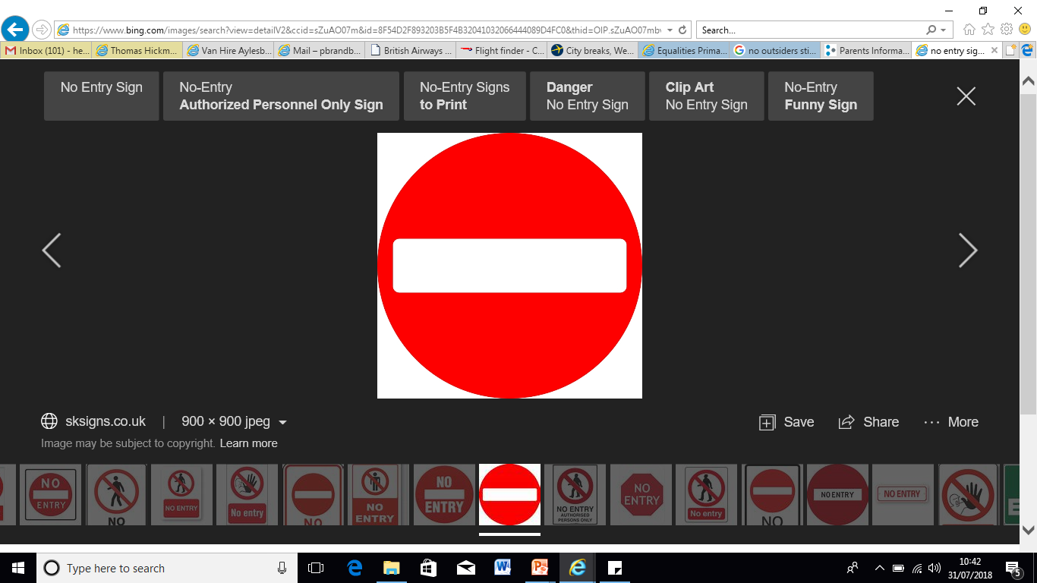
  
  No BIRD’s a bully!
  Information for parents, carers, children, teachers and governors at
  Thomas Hickman School
  Anti-Bullying
  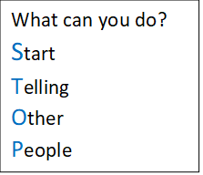
  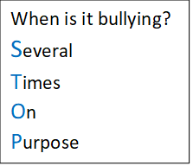
  See something
  Say something
  Sort everything.
  Everyone matters, so if you or someone you know is being bullied, tell someone you trust, immediately.
    - Thomas Hickman School, Belgrave Road, Aylesbury, Bucks, HP19 9HP
    - Telephone: 01296 485683 Email:office@thomashickman.bucks.sch.uk
    - Website: www.thomashickman.bucks.sch.uk

The School’s Role:  Our school has an anti-bullying policy which can be found on our school website.  - All children involved, particularly if it’s part of a bullying group, will be spoken to about the incident and action taken to stop it.  - Work will be done to repair and restore the children’s relationship – rebalance the power shift.  - Members of staff are trained to be alert to signs of bullying and will act promptly, sensitively and effectively.  - We will provide additional support for the child being bullied (victim) and those who have bullied (perpetrator.) This is in keeping with our Hand on Heart Behaviour and Relationship principles.  - Guidance will be given from our pastoral support team or if necessary from other external, trained professionals.  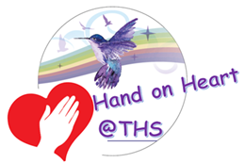  Why don’t school ‘get rid’ of the bully?  Parents are often surprised when schools don’t automatically suspend or exclude children that are bullying.  Why would a school want to work with their child's tormentor? Why not just get rid of the ‘problem child’?  There is no evidence that children are born ‘bullies’ or ‘victims’- they change their roles according to who they are with, where they are and how they are feeling.  Moving a child who bullies to another school won’t STOP the behaviour  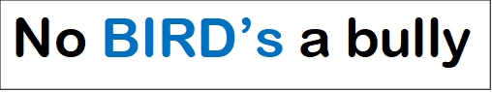  In keeping with our HoH principles the school will work with the perpetrator (or bullying group) to understand their behavior and help them develop empathy towards to understand the effect their behaviour has on others. |  |  | The child’s role:  Children should give a clear account of the incident, stating facts as soon as possible to an adult in school.  - Never feel afraid of reporting bullying  - Ask a friend to come with you for support.  - Let a peer mentor know, peer mentors know what to do and they can help. Mentors will tell the adults.  - All adults in the school will help you and support you throughout the process.  - Ask the bully to STOP - if you can, use eye contact. Tell him/her to GO AWAY  - Then tell someone immediately  IT IS NEVER YOUR FAULT.  A Parent/Carer’s Role:  Listen to your child and support by asking questions, without interrogating  - Make sure your child understands the difference between bullying and someone being mean or rude  - Don’t belittle what they are telling you. However minor it may seem to you their feelings are very real for them.  - Try to not let your child see it is upsetting you, stay calm and be patient  - Try not to jump in with advice or solve the problem. Find out all the facts first.  - Praise your child for telling you, reassure them that they have done the right thing and you will help.
2 |  |  | 3

