Facts
A machine is a man-made device.
Machines need electric power to make them move or work.
Vehicles, such as aeroplanes, cars, buses, lorries, boats, helicopters and diggers, are machines that transport people or goods.
A mechanic is a skilled worker who repairs and maintains vehicle engines and other machinery.
A robot is a machine that does a task. They only do the tasks for which they have been built.
Key vocabulary
Battery | A battery is a store of electric power.
Design | To make or draw plans for the structure or form of a model.
Electricity | A following form of energy that powers things around us.
Engineer | A person who is trained in the use or design of machines or engines or in other technologies.
Experiment | A planned test to discover something unknown.
Internet | A big network of computers around the world. We can find and share information through computers and devices.
Machine | A device with a system of parts that work together to perform a task.
Tools | Tools are objects that help us to make changes to things.

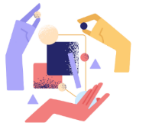

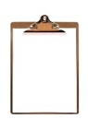
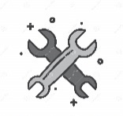
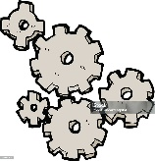


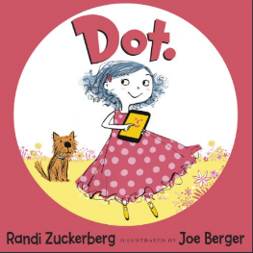
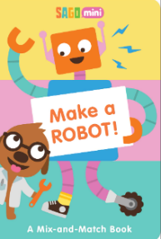
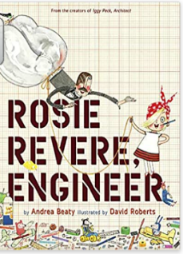
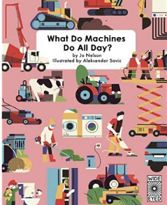
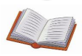
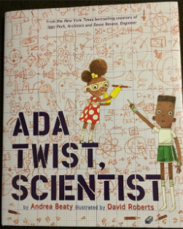
Understanding the World
We will explore the components of everyday machines. The children will explore by asking and answering question about the machines.
We will explore machines from the past and explore the similarities and differences to modern machines.
The children will be exploring different materials and some of their properties. They will be investigating forces such as push and pull and magnetic and non-magnetic materials.
What will I learn?
- I will understand that machines are all around us. I will be able to name 5 different types of machines and explain how they work.
- I will be able to explain how machines help us in our daily lives.
- I will describe how machines have changed and developed overtime.
- I can use my sounds to label the different parts of a machine.
- I will use my knowledge of different machines to be able to design my own machine.
- I will be able to represent and make different ways of the numbers to 8.

Questions to Ask:
What is a machine?
Is that machine battery powered or electric? How do you know that?
What 3 machines can you find at home?
What is the difference between a torch and a lamp?

Core texts for the term
Marvellous Machines

