Facts
Superheroes in stories and films are fictional.

Humans have 5 main senses.
Autumn is one of the 4 seasons of the year.
An author is a person who writes a story.
Key vocabulary
Blurb | A short description.
Disguise | Having a different appearance so you do not know who it is.
Title | The name of something. For example the name of a book.
Hero | A person who is admired for their courage.
Share | Taking turns to speak and listen when in conversation. Taking turns using resources within the classroom.
Superhero | A fictional character with superhuman powers.
Rescue | When someone is saved from a dangerous or difficult situation.
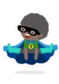

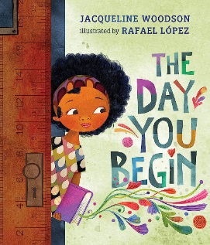
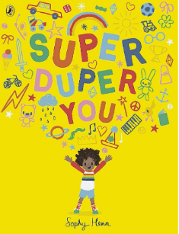
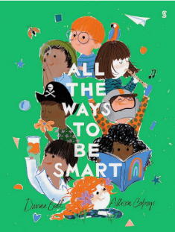
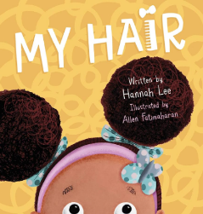
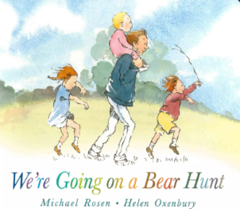
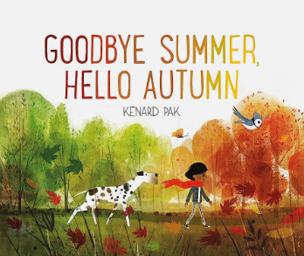
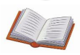



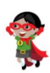
Understanding the World
Throughout this term, your child will have the opportunity to develop their understanding of the world around them. Alongside our Super You theme, this half term your child will explore the seasonal changes and learn about autumn. They will start with noticing and describing the changes in the natural around them. Focusing on key differences between Summer and Autumn.
What will I learn?
- Talk about stories and connect them to their own experiences.
- We will be talking about our family and friends.
- We will explore how we are similar or different to our friends and family.
- We will be learning about our school and routines.
- We will be exploring our senses.
- How to write my name.
- To start an activity, inviting others to join.

Stories for the term
Super Duper Me!
Questions to Ask:

Are we all the same? What makes you different?
What are you good at?
Who are your friends?
What do you like doing in class?
Can you name the 5 senses?

