Key vocabulary
Celebrate | To do something special on an important day.
Bonfire night | A celebration observed on 5th Nov in the UK.
Diwali | A 5 day festival celebrated by Hindus.
Remembrance Day | A day to remember people who helped keep us safe.
Hindus | People that follow the religion Hinduism.
Bethlehem | A town where Jesus was born.
Christian | A person that follows the religion Christianity.
Christmas | A festival celebrated by Christians on December 25th.
Nativity | The story of when Jesus was born.
Fairy tale | A story about magical and imaginary beings and lands.
Winter | A season in which the days are cold and short.
Facts
When it is Bonfire night people watch firework displays use sparklers to make patterns in the air and eat special food like hot dogs and toffee apples.
When it is Diwali people decorate their houses with diva lamps and rangoli patterns, they wear special clothes and eat special food like chapattis and samosas.
India is a long way away from England. It is a part of the Asian continent.
When it is Christmas people celebrate by decorating their houses, wearing special clothes like Christmas jumpers. Eat special food like turkey roast dinner And Christmas pudding.
Winter is one of the four seasons in a year. When it is winter it is cold and it gets dark really early. Sometimes it rains and sometimes it even snows.
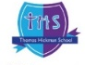

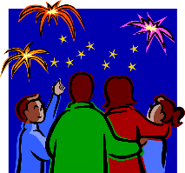
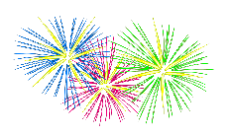

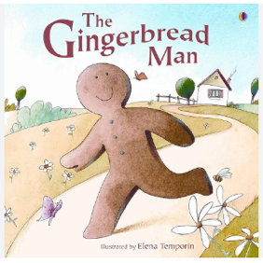

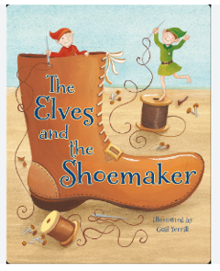
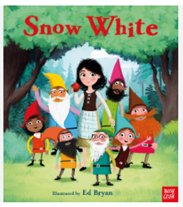
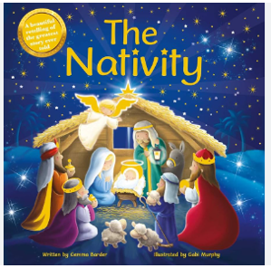
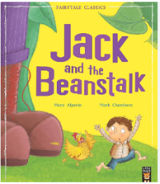
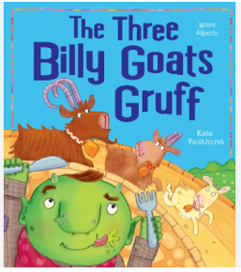
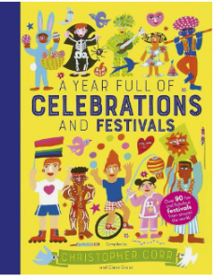
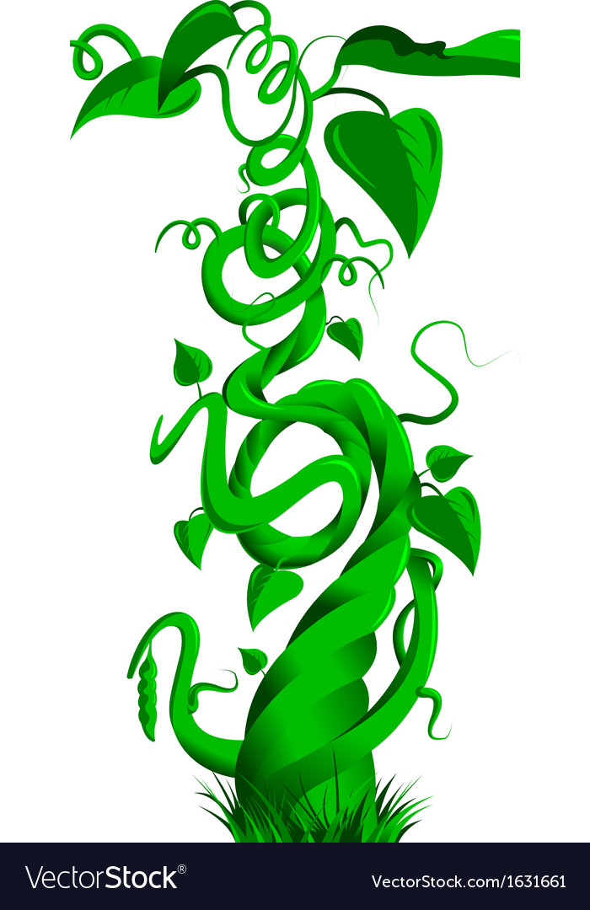
Understanding the World
The children will learn about different celebrations and festivals. They will look at how each one in celebrated and when compare to what they already know.
They children will also learn about the season winter and will be able to talk about the changes in the world around them during this season.
What will I learn?
- How to include others when working and playing.
- Be able to name different parts of a book.
- To sound out and read cvc words using my sounds.
- To hear, say and write sounds that they can hear in simple words.
- To find, subitise and represent 1, 2, 3, 4 and 5.
- Which light sources are natural and which are man- made.
- What is winter?
- Learn about different celebrations and how they are celebrated.
Questions to Ask:
What is a light source?
What is a temple?
Why do we wear poppies?
What colours can we mix to make green (like the green bean stalk?)
What is a church?

Core texts for the term
Once Upon a Celebration

