THOMAS HICKMAN SCHOOL
Our local sports clubs
The links below are just some of the incredible clubs on offer in and around Aylesbury. If your child is interested, please visit the relevant website or speak to Mr Lambert. At THS, we are happy to help you though the process of starting your child on an amazing journey, experiencing different sports and activities.

Athletics:
Vale of Aylesbury Athletics Club - https://www.voaac.org.uk/
For more clubs see: https://www.englandathletics.org/



Basketball:
Aylesbury Dux - https://www.aylesburydux.co.uk/
For more clubs see: https://www.basketballengland.co.uk/
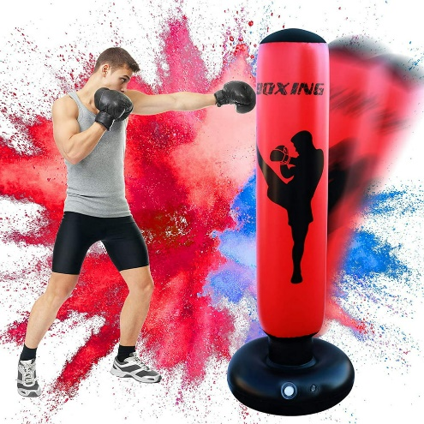

Boxing:
Aylesbury Boxing Club - https://aylesburyboxingclub.com/
For more clubs see: https://www.englandboxing.org/


Cheerleading:
Cheerleading – Aylesbury Cheerleading Academy - https://www.aylesburycheerleadingacademy.co.uk/

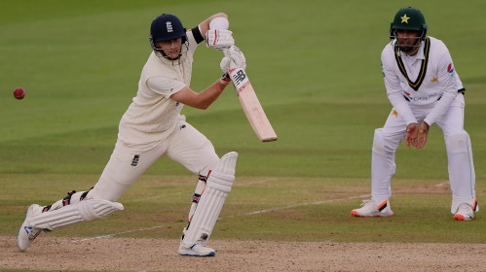
Cricket:
Dinton Cricket Club - https://www.dintoncricketclub.co.uk/
Haddenham Cricket Club - Home (haddenhamcricketclub.co.uk)
For more clubs see: England and Wales Cricket Board (ECB) - The Official Website of the ECB


Football:
Aylesbury United Girls FC - https://www.aylesburyunitedladiesgirlsfc.com/
Aylesbury Vale Dynamos - https://www.aylesburyvaledynamos.co.uk/contact
For more clubs see: England Football | Home

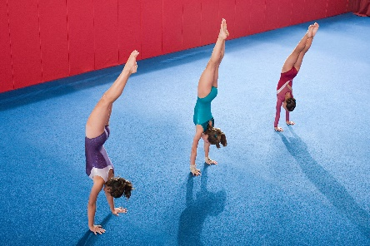
Gymnastics:
Aylesbury Gymnastics Academy - https://aylesburygymacademy.weebly.com/contact-us.html
For more clubs see: Discover Gymnastics (british-gymnastics.org)


Hockey:
Aylesbury Hockey Club - https://www.aylesburyhc.com/
For more clubs see: Play Hockey (englandhockey.co.uk)


Martial Arts:
Matt Fiddes Martial Arts - https://www.facebook.com/MFAylesbury/
ZKS Martial Arts Bucks - http://www.zksmartialarts.co.uk/aylesburytimetable.html
For more clubs see: http://www.bmaba.org.uk


Netball:
Aylesbury Junior Netball Club - https://www.ajnc.co.uk/
For more clubs see: https://www.englandnetball.co.uk/

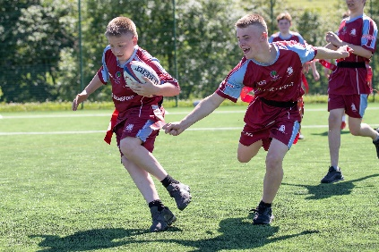
Rugby:
Aylesbury Rugby Club - http://www.aylesburyrfc.co.uk/
For more clubs see: https://www.englandrugby.com/

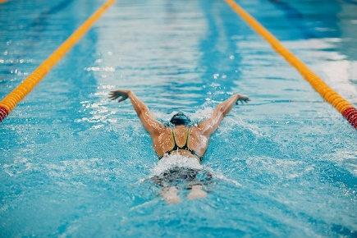
Swimming:
Aylesbury & District Swimming Club - http://adsc.org.uk/index.php
Maxwell Swim Club - Maxwell Swim Club Ltd Home (teamunify.com)
For more clubs see: https://www.swimming.org/swimengland/

Tennis & Squash:
Aylesbury Tennis & Squash Club - https://aylesburytennisandsquash.com/
For more clubs see: https://www.lta.org.uk/


