Key vocabulary
Grow | When something increases in size.
Keeping Healthy | Doing things that are good for your body.
Life cycle | The stages a living thing goes through during the stages of its life.
Plant | A living thing that grows in the Earth and has a stem, leaves and roots.
Seed | When planted will turn into a flower, plant, fruit or vegetable.
Soil | A mixture of minerals and organic material that covers much of Earth’s surface.
Unhealthy | Not making good, healthy choices for your body.
Facts
A farm is an area of land and its buildings used for growing plants and rearing animals. Farms make lots of the foods that we eat.
Food can be from plants or animals. Fruit and vegetables are from plants. Meat, milk and eggs are from animals.
Many plants grow from seeds. Plants need water, sunlight, air and warmth to grow.
Many animal babies are known by different names than the adult animal, such as cow and calf or sheep and lamb.
To stay healthy, we should eat at least five portions of fruit and vegetables a day, and exercise.
Mammals, including cows, goats, pigs and sheep, produce milk for their babies.
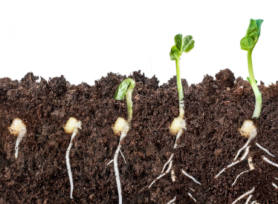
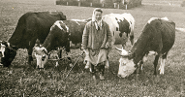
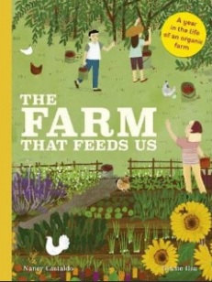
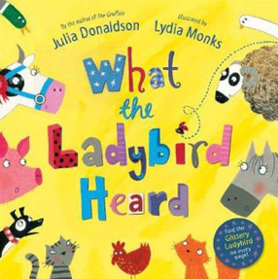
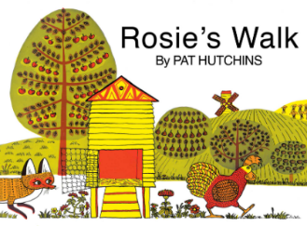
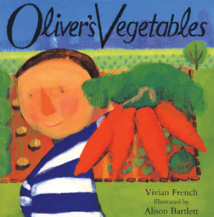
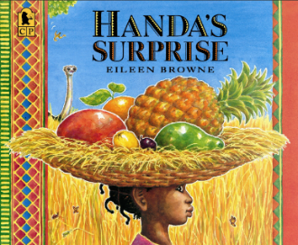
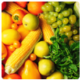
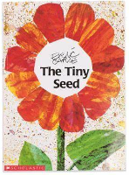




Understanding the World
The children will have the chance to try a variety of farm fresh food and even have the opportunity to plant their own vegetables and fruit. This topic will help teach the children how to stay fit and healthy by eating healthy foods, for example fruit and vegetables. They will learn that it is also important to keep our teeth clean from the sugars and understand the importance of dental hygiene.
We will be looking at farming in contrasting countries and learning that countries with a warmer (tropical) climate e.g. Africa can grow a wider variety of plants naturally.

Questions to Ask:
Which animals live on a farm?
What food is good for us and keeps us healthy?
What do plants need to grow?
Do you know the stages for a life cycle of a ….?
Core texts for the term
What will I learn?
- I will explore where food comes from.
- I can say what seeds and plants need to grow.
- I can grow some of my own plants.
- I will understand more about life on a farm.
- I will learn the names of some baby animals.
- I will be able to name some fruit and vegetables that grow in the ground, on plants or in trees.
- I will understand the importance of exercise, eating healthily and washing our hands to keep healthy.

Ready, Steady Grow

