Key vocabulary
Environment | A place where different things are. E.g. desert/ocean/forest/grassland
Exoskeleton | The hard covering that protects and supports the body of some animals.
Habitat | A place where an animal or creature lives.
Insect | Small animals with 6 legs and an exoskeleton.
Life cycle | The stages a living thing goes through during the stages of its life.
Living | Things that are alive. E.g. plants and animals.
Facts
An insect is a mini beast that has a body which is in three sections, has 2 sets of wings and 6 legs.
Antennae or also known as ‘feelers’ Insects use them to feel and smell their surroundings.
Unlike humans, most mini beasts use smell, taste and touch to explore their surroundings.
A shell helps the insect hide away from danger.
A spider is known as an arachnid not an insect.
The life cycle of a butterfly is called metamorphosis and there are 4 stages.
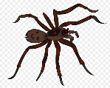
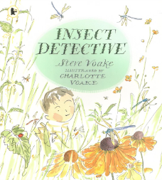
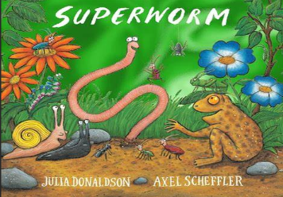
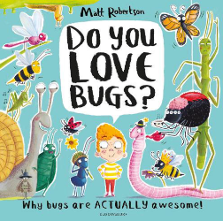
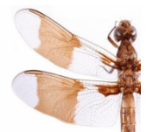

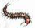
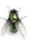
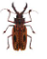
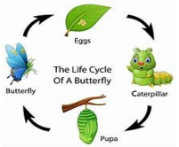
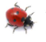
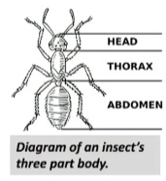
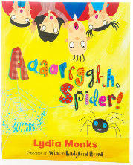
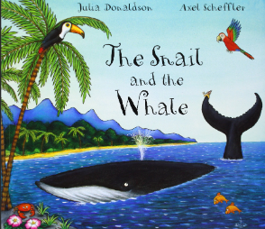
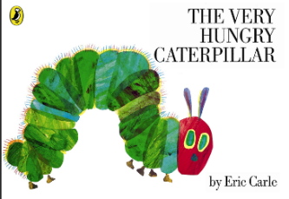



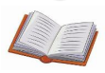
Understanding the World
The children will learn to understand the role mini beasts have on our ecosystems. Mini beasts like to eat plants and many flying insects feed on nectar from flowers. Others, such as spiders, like to eat other mini beasts. Some mini beasts eat much stranger things – for example, some beetles and ants munch on wood, worms eat dead stuff in the soil and dung beetles eat animal poo!
We will also be looking closely at the life cycle of some of the different mini beasts. We will start the term with the life cycle of a butterfly.
What will I learn?
- Learn to identify different mini beasts.
- Learning to describe and compare mini beasts
- Exploring different mini beast habitats, environments and special features.
- To look closely at the features of a mini beasts and to draw with more detail.
- How to make models of mini beasts.
- To show respect, care and concern for living things and the environment.
- To talk about change and how it makes us feel.
Questions to Ask:
Which creatures do not have legs?
How many legs does an insect have?
Are mini beasts and insects the same?
What are the four stages of the life cycle of a butterfly?
How can we take care of mini beasts and keep them safe?
Creep, Crawl and Wriggle
Core texts for the term

