Thursday 19th May 2022
Mural Masters Club
The Mural Masters club was attended by a group of 12 children from Reception -Year 4.
We worked collaboratively to create a bird wing mural to show that we are all THS birds!
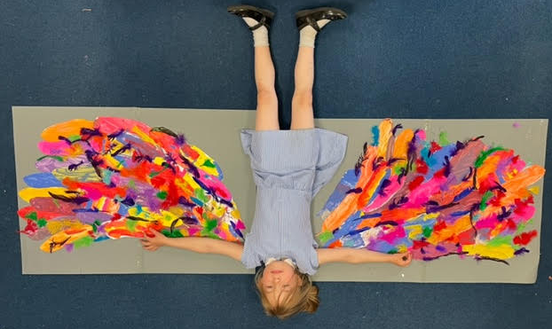
First, we painted around 50 feathers in all different colours and patterns to represent our differences. When they had dried we were able to cut them out and arrange them in the shape of two large bird wings. We then stuck the feathers down on a card backing. We added some coloured real feathers as a finishing touch and create a 3D element to our mural. Finally, we had great fun modelling our wings! Even Mrs BB couldn’t resist getting involved!



