Thursday 19th May 2022
Vincent Van Gough Sunflowers – Monitoring report
I was able to visit Year 6 during their art session based on Vincent van Gogh’s sunflowers. The session was led by a parent and grandparent of a child in Year 6 and had been arranged by Year 6 teachers. They had kindly supplied the canvasses and painted the yellow background for every child in Year 6. They led a tutorial ‘brush party’ style Art session with each class. The children used acrylic paints and metallic paints in a range of different brushstrokes to create a layered paint effect and texture inspired by Vincent van Gogh.
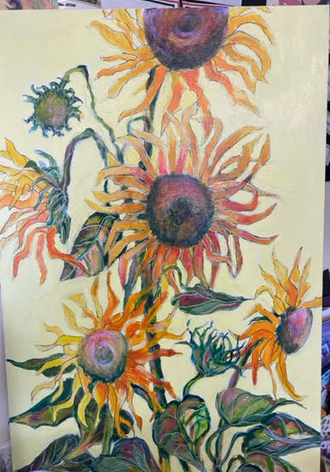
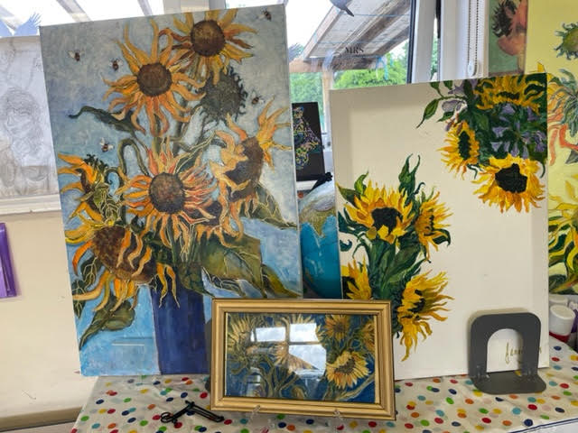
The children were all calm, focused and engaged with the session. A child with significant SEND was front and centre during the session for his class. At first, he felt very anxious about using the paints and brushes and felt as though he would fail. He was supported by an experienced teacher who was able to explain the steps again for him. He began to relax and enjoy the process of painting his picture. By the end of the session he was smiling and felt a great sense of pride about what he had achieved.

A selection of work by the artist.


