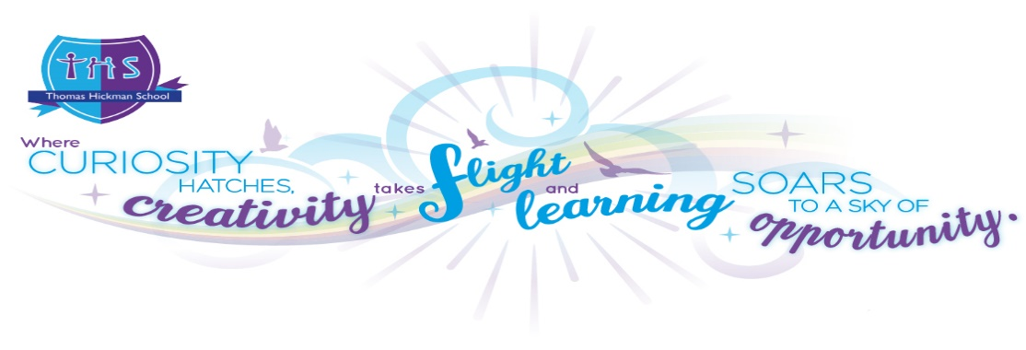
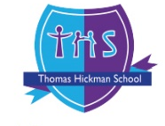

Autumn 1 | Autumn 2 | Spring 1
Super Duper Me | Once Upon a Celebration… | Marvellous Machines
  Spring 2 |   Summer 1 |   Summer 2
Creep, Crawl & Wriggle   | Ready, Steady Grow  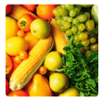 | Splash!  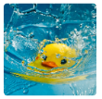

Receptions Field of Study Overview

Learning in EYFS Consists of: 3 Prime Areas: Communication & Language; Physical Development; Personal, Social & Emotional Development
4 Specific Areas: Literacy; Mathematics; Understanding the World; Expressive Arts & Design

