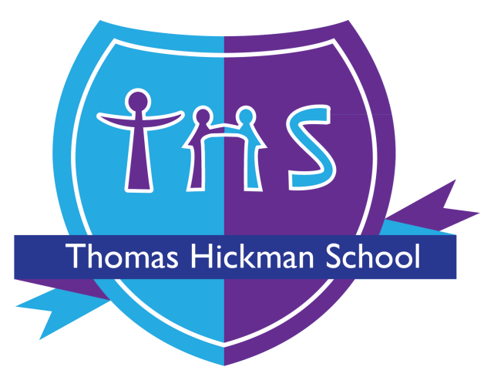

Thomas Hickman School

EYFS Policy

This policy was adopted by the Full Governing Board
SLT Member Accountable for Review | Assistant Head – EYFS Lead
Date of Last Review | September 2025
Date of next review | September 2026

Version | Summary of Changes | Date | Author(s)
Sept 25 | - Updated from Target Tracker to Tapestry  - Updated transition process | 8.9.2025 | SJO


EYFS POLICY

‘Every child deserves the best possible start in life and the support that enables them to fulfil their potential. Children develop quickly in the early years and a child’s experiences between birth and age five have a major impact on their future life chances. A secure, safe and happy childhood is important in its own right. Good parenting and high quality early learning together provide the foundation children need to make the most of their abilities and talents as they grow up.’ (EYFS, 2021)

Contents
1: Policy Statement
2: Aim
3: Organisation
4: Curriculum
5: Learning and Development
6: Behaviour
7: Assessment
8: Safeguarding and Promoting Children’s Welfare
9: Partnership with Parents
10: Transition
11: Policy Review

1 Policy Statement
  - At Thomas Hickman School we believe that a holistic EYFS experience, based on discovery and challenge within a broad and balanced curriculum, will provide children with the knowledge and skills needed to reach their full potential as they progress through our school.
  - We value and recognise the importance of working closely with parents and carers of all children, to improve their outcomes and support their individual needs.

Aims
  - To give each child a happy, positive and fun start to their school life, in which they can establish solid foundations, on which to expand and foster a deep love of learning
  - To offer each child a wide range of new and exciting experiences and give them the opportunity to consolidate, explore and test out their ideas
  - To provide a range of child-initiated, adult-initiated and adult focused activities indoors and outdoors
  - To enable each child, through encouragement and high expectations, to develop to the full, socially, physically, intellectually and emotionally
  - To offer a structure for learning, that has a range of starting points and unlimited opportunity for development
  - To encourage children to develop independence, within a caring, secure and inclusive atmosphere
  - To support children in building relationships, through the development of social skills such as cooperation and sharing
  - To provide opportunities for children to become confident in taking risks in their learning
  - To help each child to recognise their own strengths and achievements, through experiencing success and developing the confidence to work towards personal goals
  - To develop a strong partnership between home and school where parents/carers regularly contribute to their children’s learning journeys and work together to address next steps in children’s development
  - To provide a smooth transition on entry, from Nursery to Reception and into Year 1

3 Organisation
The Foundation department is split into 2 Reception Classes, Muddy Ducks Pre-School (3-4 year olds) and Muddy Ducks Nursery (2-3 year olds). All classes have access to an outside learning environment as well as their indoor classroom.

3.1 Space requirements
3.1.1. 2.5m per child aged under 3.
3.1.2. 2.3m per child aged 3-5. County guidance each class has maximum of 30 pupils.

3.2 Staffing and Employment (See Safe Recruitment Policy)

3.4 Qualifications, training, skills and Knowledge/staff: child ratios
3.4.1. For children aged two:
• There must be at least one member of staff for every five children (1:4 within Muddy Ducks Nursery).
• At least one member of staff must hold an approved level 3 qualification.
• At least half of all other staff must hold an approved level 2 qualification.
3.4.2 For children aged three and over in registered early years provision at any time where a person with Qualified Teacher Status, Early Years Professional Status, Early Years Teacher Status, or another approved level 6 qualification is working directly with children:
• There must be at least one member of staff for every 13 children.
• At least one other member of staff must hold an approved level 3 qualification.
3.4.3 For children aged three and over in registered early years provision where a person with Qualified Teacher Status, Early Years Professional Status, Early Years Teacher Status, or another approved level 6 qualification is not working directly with children:
• There must be at least one member of staff for every eight children.
• At least one other member of staff must hold an approved level 3 qualification.
• At least half of all other staff must hold an approved level 2 qualification.
 | N1 | N2 | R
Keyperson role | - Update Tapestry with observations regularly  - Regularly update children’s work on display  - Complete adult directed activities with key children  - Support and extend children’s child-initiated activities  - Work with parents to support children’s next steps of development  - Meet with CT each half term to update assessment data and audit evidence in books. |  | Reception class teachers with support from class TAs/HLTA

3.6 Health and Hygiene (see Health and Safety Policy)
At least one member of foundation staff has Paediatric First Aid certificate. We aim for all EYFS staff to have a valid Paediatric First Aid qualification and the WELTA monitors this.

3.7 Resources
We plan a learning environment, both indoors and outdoors, that encourages a positive attitude to learning. We use materials and equipment that reflect both the community that the children come from and the wider world. We encourage the children to make their own selection of the activities on offer, as we believe that this encourages independent learning.

3.8 Risk Assessment (see school Risk Assessment policy/EYFS risk assessment forms)

3.9 Premises (see school health and safety policy

4 The Curriculum
4.1 The EYFS is based on the following four principles;
- Every child is a unique child, who is constantly learning and can be resilient, capable, confident and self-assured.
- Children learn to be strong and independent through positive relationships.
- Children learn and develop well in enabling environments with teaching and support from adults, who respond to their individual interests and needs and help them to build their learning over time. Children benefit from a strong partnership between practitioners and parents and/or carers.
- Importance of learning and development. Children develop and learn at different rates.

4.2 Characteristics of Effective Learning
Staff link observations of children’s learning to the three characteristics of effective learning;
- Play and Exploring – engagement
- Finding out and exploring
- Playing with what they know
- Being willing to have a go
- Active Learning – motivation
- Being involved and concentrating
- Keeping on trying
- Enjoying achieving what they set out to do
- Creating and Thinking Critically – thinking
- Having their own ideas
- Making links
- Choosing ways to do things

4.3 The Thomas Hickman Early Years setting promotes children’s independent learning.
4.4 Observation by all staff ensures children’s needs and next steps are provided for by changes being made to the learning environment and resources provided or focused activities as appropriate.
4.5 Children are encouraged to make decisions in their learning by saying what they will play with and at the end of the session suggesting what they have done, and what they could do next.

4.6 Areas of Learning
The EYFS is made up of seven areas of learning;
- Prime areas
- Personal, Social and Emotional Development
- Communication and Language
- Physical Development
- Specific areas
- Literacy
- Mathematics
- Understanding the World
- Expressive Arts and Design
The areas of development are delivered through a balance of adult led and child initiated activities. A child achieving a good level of development will achieve the Expected Early Learning Goal in each of the Prime areas and Literacy and Maths by the end of Reception.

4.7 Planning
At Thomas Hickman School children follow a contagious and courageous ‘Flying Start’ Curriculum. Long term planning covers annual events such as Eid, Christmas, fireworks night. Half termly planning is based on Fields of Study to ensure coverage of all areas of the curriculum and the children can know and do more. Within each field of study children will access a ‘wow’ starter, experience and ‘finale’ which parents are invited to. The weekly planning is adapted from the half term planning taking into account observations made of children to identify their needs and next steps. Target groups address the additional needs of SEN, EAL, PP implemented by Teaching Assistants.
 | N1 | N2 | R
Planning | 1 plan per week to include;  - Enhanced provision (including key songs and texts)  - Group time/adult directed activities/individual focuses as appropriate. | plan per week to include;  - Group time focus  - Adult directed activities  - Enhanced provision | Weekly plan to include;  - Literacy/Maths Group sessions and focus tasks  - Field of study sessions and wider curriculum eg ICT,PSED  - Enhanced provision  - RWI phonics sessions
5 Learning and Development
Our policy on teaching and learning defines the features of effective teaching and learning at Thomas Hickman. These features apply across the school from Foundation through to Key Stage 2.

5.1 Reading Books
Reading books are changed regularly in Reception and linked with their learning in RWI. In addition children are encouraged to borrow library books to share at home.

5.2 Across EYFS, FOS achievements through focused work will be celebrated on display. The Tapestry observations will record children’s individual independent achievements and be used to support assessment judgements that are made each term.

6 Behaviour (See school Behaviour policy)

7 Assessment
7.1 Continuous assessment of pupils’ progress is an essential aspect of the EYFS. At Thomas Hickman we make regular assessments of children’s learning, and we use this information to ensure that future planning reflects identified needs.

Assessment | Pre-N1/N1 | N2 | R
Baseline | - Within 3 weeks of starting  - September, January and April intake | - Within 3 weeks of starting | - Within 3 weeks of starting
Assessment update | - Attainment updated on Insight  - Phase leader/CT meet with keyworkers to discuss data and identify areas to focus on and next steps. | - Attainment updated termly on Insight  - Phase leader/CT meet with keyworkers to discuss data and identify areas to focus on and next steps. | - Attainment updated termly on Insight  - Phase leader meet with CT to discuss data and identify areas to focus on and next steps.
Assessment update | - Matrix focused on PRIME AREAS | - Matrix focused on PRIME AREAS | - Matrix focused on GLD AREAS
Assessment update | Each term Progress meeting – discuss;  Progress of individuals/class/groups (including gender, PP, EAL, class, SEN)  Attainment of individuals/class/groups (including gender, PP, EAL, class, SEN)
Assessment update | Record how progress and attainment will be targeted on back of planning  Key children and areas identified  Reviewed regularly during PPA sessions

7.2 Assessment Tracking Cycle
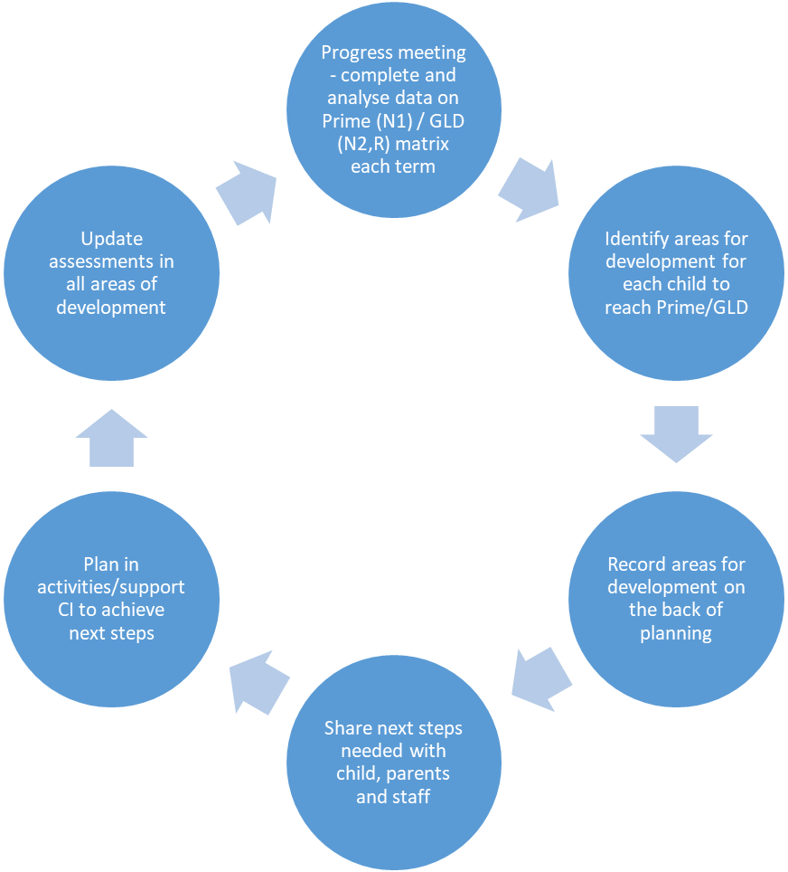

8 Safeguarding and Promoting children’s Welfare

8.1 Safeguarding (See Thomas Hickman School Child Protection Policy)

8.2 Premises and Security (See Health and Safety Policy)

8.3 Outings (See Educational visits Policy)

8.4 Equality of Opportunity (See separate school admissions policy, school Equalities and Cohesion policy)

8.5 Records, Procedures, Data and Confidentiality (see Assessment and Data protection policies)

8.6 Nappy changing (See Intimate Care Policy)

9 Partnership with Parents

We believe that all parents have an important role to play in the education of their child. We recognise the role that parents have played, and their future role, in educating their children. We do this through;
- talking to parents about their child before their child starts in our school.
- providing children with the opportunity to spend time with their teacher before starting school during transition sessions.
- encouraging parents to talk to the child’s teacher if there are any concerns.
- there are parents’ meetings in Autumn, Spring and Summer terms at which the teacher and parent discuss the child’s progress and next steps.
- Nursery, Preschool and Reception parents receive a written report on their child’s attainment and progress at the end of the school year.
- having flexible admissions arrangements that enable children and parents to become secure, and by allowing time to discuss each child’s circumstances.
- providing a range of activities throughout the year that encourage collaboration between child, school and parents.
- parents are welcome to come and talk to the teacher at the beginning and end of each session.
- parents are encouraged to complete observations on Tapestry of their child’s achievements at home

 | N1 | N2 | R
Parental engagement | - Attend new to Nursery settling sessions  - Accommodate a Home Visit with teaching staff | - Attend new to Nursery settling sessions  - Accommodate a Home Visit with teaching staff | - New to Reception sessions  - Current Nursery parents have opportunity to meet Reception staff on move up day or Stay and Play sessions  - Pre-school setting visits and home visits
Parental engagement | - baseline sheet completed to show how children would react in different situations.  - include what children can do and next steps parents would like children to achieve.
Parental engagement | - Parents are encouraged to complete observations on Tapestry of their child’s achievements at home
Parental engagement | - At parents meetings ‘tree’ report is shared and parents identify next step they would like their child to achieve.

Information and Complaints
(see school Complaints procedure)

10. Transition

 | On entry to N1 | On entry to N2 | On entry to Reception | On entry to Year 1
New admissions | - Attend 2 x new to Nursery settling sessions with parents  - Transition is planned with the individual in mind, and can be adapted with the needs of the child in mind. |  | - Pack forms and information  - Three stay and play sessions for children to attend  - Families new to Thomas Hickman in Reception will also have a home visit.
Children currently on roll |  | - series of move up sessions within current Nursery sessions (July) | - series of move up sessions (July)  - letter to inform staff of PE kit, book bag, session times  - AM/ PM chn visit their new setting in small groups  - Three stay and play sessions for children to attend | - series of move up sessions (July);  - begin with Yr 1 staff supporting children in Reception environment  - Then Rec children meet new Yr 1 teachers in Yr 1 classes, supported by current Rec TAs  - Then Rec children in Yr1 environment with staff they will have in September  - Current Reception parents have opportunity to meet Year 1 staff on move up day.

11 Policy Review
It is the responsibility of all EYFS staff to follow the principles stated in this policy. The EYFS governor will discuss practice with the practitioners regularly and provide feedback to the whole governing body, raising any issues that require discussion.

This policy will be reviewed annually.

See also:
EYFS Guidance
EYFS Equality of Opportunity policy
School SEN policy
School admissions policy,
School Equalities and Cohesion policy
School learning and teaching policy
School monitoring and evaluation policy

