BUCKINGHAMSHIRE COUNTY COUNCIL

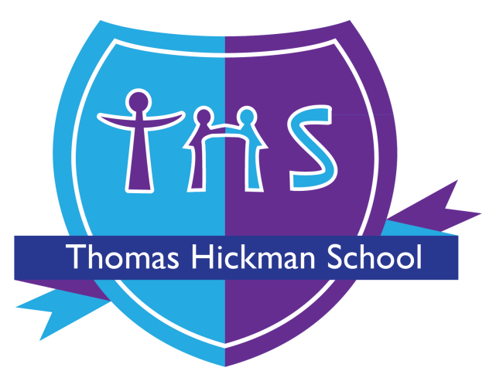

Thomas Hickman School
Special Educational Needs and Disabilities Policy

Adopted by Thomas Hickman School

Adopted by Governors Full GB: July 2012
Governing committee accountable for review Performance
SLT member accountable for review: Abi Hunter
Date of last review: September 2025
Date of next review: September 2026 (subject to changes in Government Policy)

Signed: ……………………………………………………………. Date: …………………………………

B.I.R.D.S

Our school values underpin everything that our school community does.

Brave | We face challenges with strength and are willing to ‘have a go’ and take risks.
Inspirational | We are inspirational citizens and there is no limit to what we can achieve for ourselves and our community.
Respectful | We respect everyone as individuals regardless of differences and do the right thing even when no one is watching.
Determined | We are determined to succeed and strive for greatness, even when giving up is the easier option.
Scholarly | We gain knowledge by being curious; empowering us to create the lives we want for ourselves. We call this ‘growing our brains’.

We have a rich and varied school community, and we celebrate our differences and support each other so that no BIRDS fly alone. We believe that there are No Outsiders Here at Thomas Hickman School…
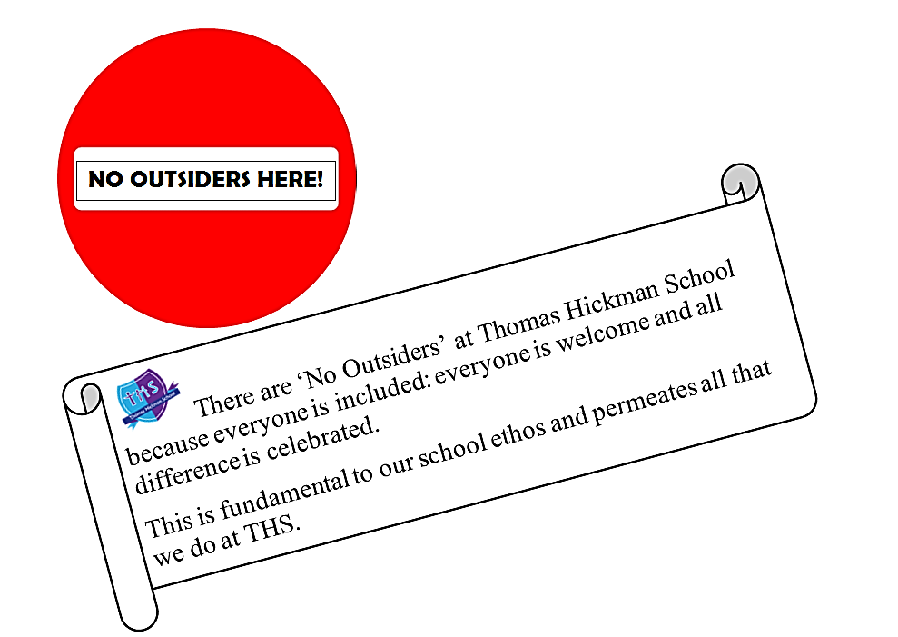

At Thomas Hickman School, we endeavour to improve the lives of children, young people and families. We celebrate our rich diversity and take steps to tackle all kinds of bullying. In doing so, we believe that children will attain more at school and our community will be happier and more successful.

We celebrate all our children and their families without discrimination.

We are a caring community where our whole-school, BIRDS charter is built on mutual trust and respect for all, regardless of race, religion, ethnicity, sexual orientation, gender identity, disability, age or gender. The ‘No Outsiders’ message fulfills our duty to promote diversity and prepares our children for life in modern Britain.

‘No Outsiders’ is British Law and supports the Equality Act to ensure that everybody is treated equally and without prejudice.



As a Trauma Informed School (TIS) staff at Thomas Hickman understand that Adverse Childhood Experiences (ACEs) will impact a child’s ability to manage school life and inhibit their ability to learn and reach their ambitions.
Research shows that children with 3 Aces or more are;
- Twice as likely to experience academic failure.
- Five times as likely to have attendance problems
- Twice as likely to be overweight
- Thirty-two times more likely to have behaviour problems

For every additional ACE there is an increased risk of learning difficulties, behaviour problems, obesity and mental health issues later in life.

Staff at THS know that emotionally available adults in school actually shape the neurocognitive development of executive functions in the child’s frontal lobe and therefore interrupt the impact of ACES – in essence, adults who have a strong relationship with a child can redirect a child’s future.

Therefore, staff work tirelessly to:
- Understand a child’s ‘story’ – what’s happened to them in their little lives so far, not ‘what’s wrong with them’?
- Develop secure attachments with the children in their care.
- Ensure that children are kept safe, are seen and soothed and that they feel secure.
- Help children to understand how the 3 main areas of the brain work to support their emotional literacy, co-regulation and, ultimately, work towards self-regulation all of which are far more challenging for a child with ACES.

Hand on Heart is a whole school approach that encompasses THS alongside Norfolk Steps methodology to ensure that our school community is a place where children are ready to be curious, take flight and learn well, leading to a sky of opportunity and a successful adult life.



Thomas Hickman Special Educational Needs (SEND) Policy

September 2021

Introduction

At Thomas Hickman, we recognise every child’s right to a broad, balanced, relevant and challenging curriculum.

Whilst at THS we follow the requirements of the National Curriculum, we are confident that there is time and space in the school day, each week, term and year to range beyond its specifications. It is during these opportunities that we make our Flying Start curriculum, bespoke to our school, for our specific learners.

To explain further, the National Curriculum provides only an outline of core knowledge, around which skilled leaders and teachers develop exciting and stimulating lessons to promote the development of pupils’ knowledge, understanding and skills as part of the wider school curriculum. Therefore, pupils at Thomas Hickman School are exposed to our Contagious and Courageous Flying Start Curriculum, which is creative, rich and deep, but most importantly distinctive; designed to meet individual needs.

It is ‘contagious’ because we want all children to ‘catch’ learning – there is nowhere to hide from it, every minute of every day is a learning opportunity.

It is ‘courageous’ because we won’t narrow the curriculum to isolate ‘Maths and English’ lessons, and we won’t teach to tests. We will not stop the curriculum in the Spring term to ‘cram’ for SATs. We will be brave and deliver PE or wider curriculum lessons first thing in the morning if we choose and consider how English and Maths can be incorporated into these.

Diversity is recognised as a valuable source of enriching and supporting the learning of all – there are “No Outsiders Here” at Thomas Hickman School.

A minority of children have particular learning or behavioural requirements or difficulties that could create barriers to learning. These requirements are likely to arise as a consequence of a child having Special Educational Needs. Teachers take account of these requirements and make reasonable adjustments, where necessary, to support individuals or groups of children in order to enable them to participate effectively in our Contagious and Courageous curriculum and assessment activities. The support of children with SEND is done in a holistic way where adaptations and support in class through Ordinarily Available Provision (OAP) are enhanced by specific interventions for individuals or small groups.

Children may have Special Educational Needs either throughout or at any time during their school career. This policy ensures that curriculum planning and assessment for children with Special Educational Needs takes account of the type and extent of the difficulty experienced by individual children.

Aims and objectives
The aims of this policy are:
- To create an environment that meets the Special Educational Needs of each individual child.
- To ensure that the Special Educational Needs of children are identified, assessed and adequately provided for.
- To make clear the expectations of all stakeholders in the process.
- To identify the roles and responsibilities of staff in providing for children’s Special Educational Needs.
- To enable all children to have full access to all elements of the school curriculum and school life.

Educational inclusion
Through appropriate curricular provision we respect the fact that children:
- Have different educational and behavioural needs.
- Have different aspirations.
- Require different strategies for learning.
- Acquire, assimilate and communicate information at different rates.
- Need a variety and range of different teaching approaches and experiences.

Teachers respond to children’s needs by:
- Supporting every child’s progress, irrespective of whether they have physical, sensory, emotional, behavioural, specific or general learning needs.
- Planning to develop children’s understanding through the use of all available senses and experiences.
- Planning for children’s full participation in learning and in physical and practical activities by applying reasonable adjustments and differentiation to support their learning and break down barriers.
- Helping children, through reasonable adjustments in our Behaviour Policy, to manage their behaviour and to take part in learning effectively and safely.
- Helping individuals to manage their emotions, particularly trauma or stress, and to take part in learning.

Special Educational Needs – The Graduated Approach (3 distinct groups)

Children with Special Educational Needs will have some aspects of learning, behavioural or medical difficulties that call for provision that is different from or additional to normal quality first teaching. The earlier that a need is identified, the quicker that appropriate action can be taken to support the child and their progress.

The school uses the recommended graduated approach for the identification, assessment of and provision of pupils with SEND. This involves a decision-making process based on in-class assessments and pupil tracking. The Special Educational Needs Coordinator is consulted about decisions involving SEND for a particular child and to discuss suitable provision and intervention.

If a pupil is deemed to have SEND, then the class teacher will produce a Learning Plan which outlines their needs and strategies for support. They follow the Assess, Plan, Do, Review process from the SEND Code of Practice and every plan is reviewed in Autumn 1, Spring 1 and Summer 1; unless it is deemed necessary to review a particular plan earlier.

Pupils with persistent challenging behaviour, which contravenes our Behaviour and Relationships Policy will have access to a range of behaviour support strategies (in line with our HOH approach) and reasonable adjustments to meet their needs; examples of these adjustments may include a Learning Plan, a Positive Intervention Plan (PIP), support from a Specialist Behaviour Teacher/PRU, time out, positive reward systems, social skills groups, individual therapy sessions with our in-house Child Therapist and Wellbeing Lead and our lunch time ‘Aviary’ for children who are unable to cope on the busy main playground. This is not an exhaustive list: each child is different, and each adjustment will be unique in its design to support them to succeed.

Children who do not make the expected progress, despite quality first teaching and supporting intervention, may need to be referred to an outside professional for further assessment and investigation.

Children with complex SEND Needs, who are in receipt of a very high level of support in school may be put forward for an Education, Health and Care Needs Assessment. This involves submitting evidence to the County SEN team, who will then ascertain if a child needs further assessment or additional funding.

Children in EYFS who are needing additional support but who we have not yet clearly identified the level of their needs or whether it is a long-term need or simply an aspect of children developing at different rates, are placed on an ADPR plan, this is a one page document where the Assess Plan Do Review process can be recorded and monitored for impact. A decision will then be made, depending on progress of the child, whether they need to be added to the SEND Register and have a full Learning Plan put in place or whether their needs can be met within the bounds of quality first teaching.

Quality First Teaching
It is understood that the school’s usual differentiated curriculum and strategies will provide adequate support for the needs of most children. Teachers deliver our “Contagious and Courageous” curriculum using a variety of engaging and challenging activities.

However, it will be the case that for some pupils this will not be sufficient to address their individual needs. For those pupils the school will need to provide reasonable adjustments, interventions or different ways of approaching learning in class that is additional to or different from those provided as part of the school’s usual differentiated curriculum, our Principles of Instruction. This is where reasonable adjustments and OAP are put in place, both in and out of the classroom, to support needs in a more bespoke manner.

All children are assessed and monitored regularly in order to understand how they are progressing towards the year group age related statements. Any testing takes into account access arrangements so that children can build normal routines for assessment points. These access arrangements are indicated in the Learning Plan. Assessment for SEND children includes:
- Interventions are baseline assessed and then re-assessed at regular intervals to ensure that it is having impact, and any relevant adaptations/changes can be made.
- At each review point (Autumn 1, Spring 1 and Summer 1), staff judge whether SMART targets have been met, partially mat or not met so we can see small steps of progress.
- PIRA and White Rose Maths tests are taken each term (by all children from year 1-6) and the outcomes of these are used to determine small steps of progress and identify children who need further support.

Learning Plans
This document records the support provided within the school’s delegated SEND budget. It is designed for pupils with a need that requires something additional to and different from quality first teaching in order to make progress towards Age Related Expectations.
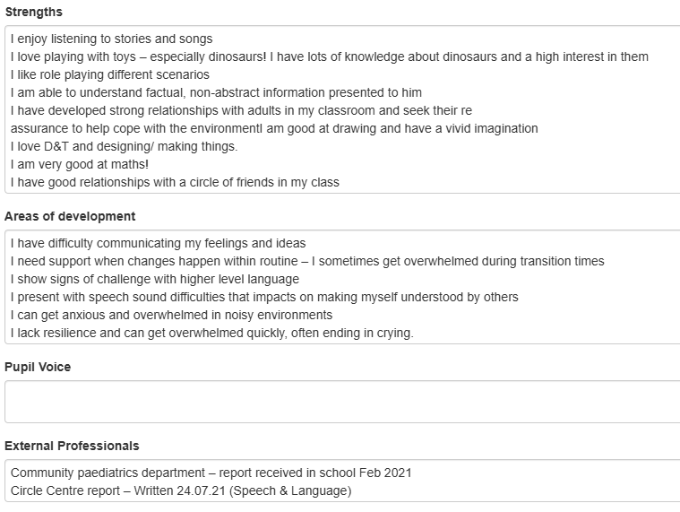
The Strengths, Areas of Development, Pupil Voice, External Professionals, Assessment information and OAP boxes create a detailed picture of the child’s current needs.

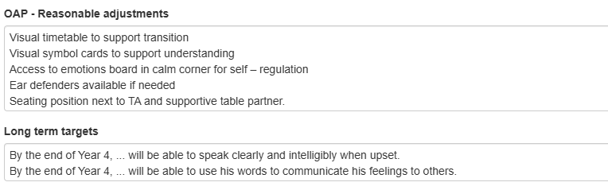

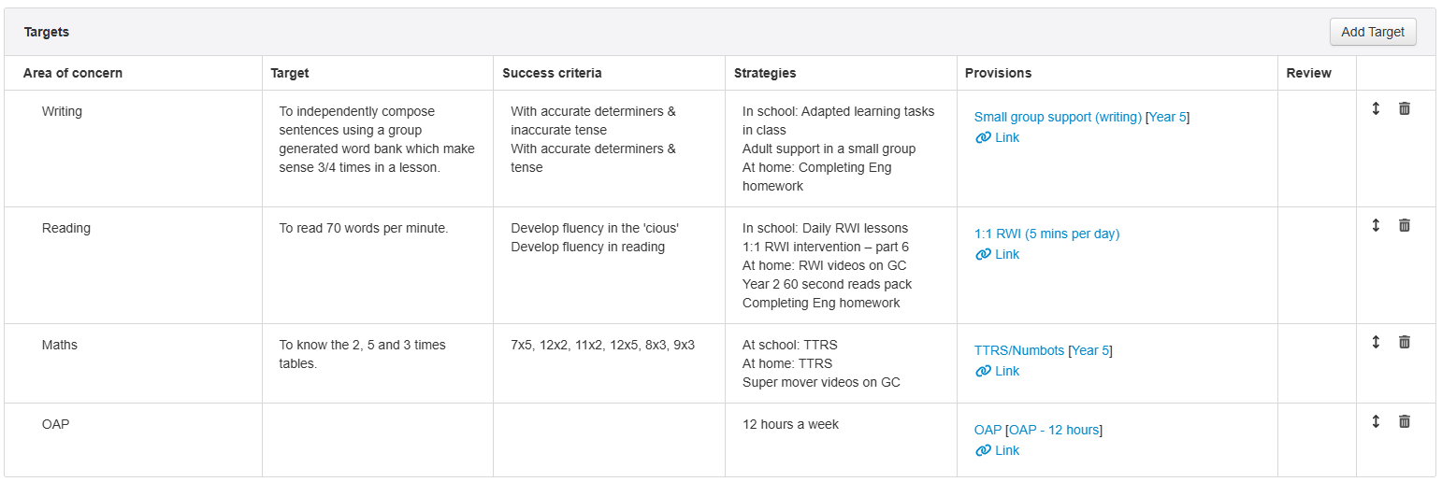
Each term staff produce SMART Targets which will be the focus of targetted support and intervention that will enable the child to make progress towards longer term goals.
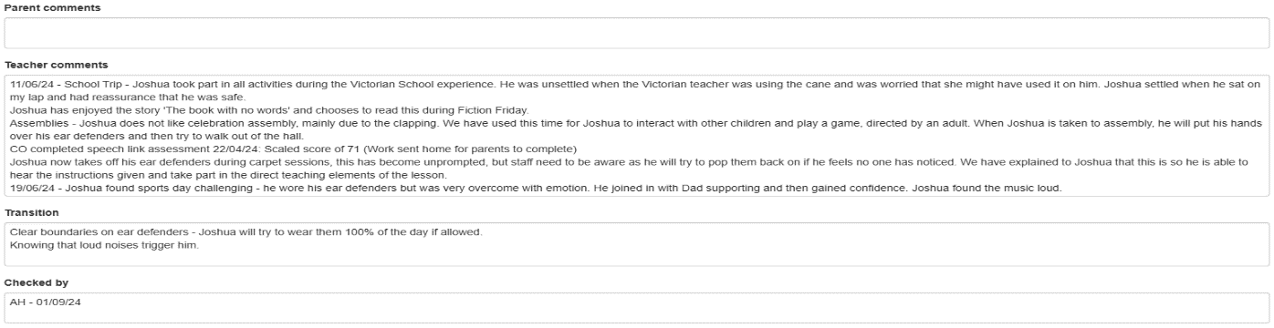
The spaces for teacher and parent comments ensure that all stakeholders have an opportunity to contribute. Transition is an essential part of our SEND support and is carefully planned by staff ready for the child’s next teacher to ensure nothing is missed.

County Assessment
If the needs of a pupil are still not being met by the school despite adjustments and support, the school may consider requesting for Statutory Assessment (EHCNA which could lead to an Education Health and Care Plan being issued).

The needs of the child are considered to be paramount in this and the school must prove that the child is already getting a high level of support per week, not making progress and/or being at a very low level of attainment. Schools provide evidence of support and impact over time and County ‘Forum’ panels consider the request and make the decision about whether to assess or not. If they agree to assess then County will commission a range of professionals to carry out assessments and produce a report. This assessment will help to determine whether an EHCP is required and, if it is, the level of support that County will provide on top of the existing 13.5 hours provided by the school.

In some rare cases an EHCP may be issued that does not include any additional hours of support; it will outline the child’s needs, set targets and indicate any additional external support, but it won’t provide any additional funding.

The role of the Governing Body

The Governing Body should have regard for the Code of Practice when carrying out duties towards all children with SEND. They will appoint a link governor who will liaise with the Head Teacher and SENDCO to ensure that the necessary provision is made for pupils with SEND.

The SENDCO will also produce regular termly reports so that Governors are aware of actions and impact.

The Role of the SENDCO (Assistant Head of Inclusion)

In our school the Assistant Head:
- Manages the day-to-day operation of the policy.
- Line manages the majority of the Assistant Teachers across the school.
- Co-ordinates the provision for and manages the responses to children’s special needs.
- Supports and advises colleagues on reasonable adjustments, support in class, strategies and interventions where necessary.
- Maintains the school’s SEND register and updates Sims.net on a termly basis.
- Contributes to and manages the records of all children with Special Educational Needs.
- Manages the school-based assessment and completes the documentation required by external agencies and County.
- Acts as the link with parents.
- Maintains resources and a range of teaching materials to enable appropriate provision to be made.
- Acts as link with external agencies and other support providers.
- Monitors and evaluates the special educational needs provision and reports to the Governing Body.
- Manages a range of resources, human and material, linked to children with Special Educational Needs.
- Works closely with school colleagues to ensure a holistic approach to the education of pupils to ensure that all pupils make progress regardless of their individual starting points.

Allocation of resources
Resource needs and implications should be clearly detailed on individual Learning Plans. The School Development Plan is used to identify and drive strategic planning, whole school initiatives, targeted improvements and training needs in order to raise the effectiveness of SEND support across the school community. The Headteacher informs the Governing Body of how the funding allocated to support Special Educational Needs has been employed.

Assessment
- Early identification is vital. The class teacher will inform the SENDCO of any concerns they have about a child’s needs and/or development via the concern form. These will be discussed as soon as possible. Parents must also be informed at the earliest opportunity to alert them to concerns and enlist their active help and participation.
- With early intervention in mind, the SENDCo and EYFS Lead meet regularly to discuss children in the Early Years who have already been identified as having SEND or are causing concern. They discuss progress and plan which children require additional support, external agencies or additional funding.
- The class teacher and SLT will assess and monitor the children’s progress in line with existing school practices.
- The SENDCo and teaching staff will work closely with parents to plan appropriate reasonable adjustments, differentiation and targeted intervention.
- Class Teachers and Assistant Teachers keep records of any interventions and track progress from a baseline assessment via Insight. This information then informs Learning Plans, and a central record of intervention impact is kept within the provisions section of Insight. Each term relevant changes are made to individual provision through the review aspect of the SEND process.
- Children are also assessed using PIRA (reading) and White Rose (maths) in order to gauge their working age and plan accordingly. Results for all children are reported, tracked and monitored by the class teacher and SLT.
- Staff monitor the progress of SEND children via class records and INSIGHT data tracking.

Access to our Contagious and Courageous Curriculum
All children have an entitlement to a broad, balanced and challenging curriculum, which is differentiated to enable children to:
- Understand the relevance and purpose of learning activities.
- Experience levels of understanding and rates of progress that bring feelings of success and achievement.

Children with SEND needs are front and centre in the classroom: the class teacher is responsible for the day-to-day planning and delivery of their adjusted provision using a range of strategies to meet children’s Special Educational Needs. Children with SEND needs work with both the class teacher and TA at different times of the week. Lessons have clear learning objectives; work is differentiated, and reasonable adjustments are made. Ongoing assessment is used to inform the next stage of learning.

We support children in a manner that acknowledges their entitlement to share the same learning experiences that their peers enjoy. Wherever possible we do not withdraw children from the classroom situation. There are times though when, to maximise learning, we ask the children to work in small groups, or in a one-to-one situation outside the classroom. Keep-up not Catch-up sessions happen regularly in classes and year groups to capture any children (regardless of needs or attainment) who have not quite grasped the concept in class that day but, with a little more input, will feel more secure and ready for the following day’s learning. Interventions are there to support the learning that is happening in class so that the children can rehearse or apply that knowledge and understanding, an in turn making the classroom more accessible.

Provision for SEND
Assistant Teachers work in classes to support children with additional needs and those with EHCPs during lessons. Some withdrawal support for specific interventions is also provided, however these interventions are kept to a minimum and are carefully tracked for impact and changes are made when necessary. The provision is flexible and relevant to the needs of the child and promotes self-esteem. Withdrawal does not jeopardise the child’s right to a broad and balanced curriculum.

The school has access to a range of external professionals including the following: Educational Psychologist, SALT, Cognition and Learning, Community Paediatrician, Occupational Therapy, EYFS SEND Advice, CAMHS, Young Carers, and counselling support for children with both EAL and SEND.

Partnership with parents
- The school prospectus contains details of our policy for Special Educational Needs, and the arrangements made for these children in our school.
- The knowledge, views and first-hand experience that parents have regarding their children is valued for the contribution it makes to the child’s education. Parents are seen as partners in the education process.
- All parents are welcome to contact the SENDCo if they have concerns about special educational provision. Parents are strongly encouraged to keep in contact with their class teacher regarding their child’s progress. The home-school agreement outlines how parents can support their child’s learning at home.
- In addition to termly parents evenings, teaching staff meet with the parents of SEND children each term to discuss their learning plan. They share any progress, discuss interventions and this gives all parties a chance to update and provide any other information relevant to that child’s story.

Monitoring and evaluation
- The SENDCO is involved in supporting teachers, in drawing up Learning Plans and discussing appropriate support and adjustments for children. There is a regular cycle of book looks, learning walks, observations, data analysis and reviewing of support plans. The Senior Leadership team also hold regular meetings to review the work of the school in this area. The SENDCo and the named SEND Governor also hold termly meetings.
- Learning Plans are reviewed each term (or sooner if required). A face-to-face meeting is held with parents/carers to discuss SEND provision specifically – this meeting is held during parent consultations unless additional time is needed.
- Assistant Teachers who are running intervention groups, record their sessions using Insight. They also carry out a baseline assessment at the start of the intervention and check progress at regular intervals. This ensures that they can adapt their sessions to suit the needs of the children in each group. This work is supported by the Class Teacher and SENDCo.
- Children’s individual progress is also tracked daily using Assessment and Feedback books in class and Insight Tracking on a termly basis. This information is used by teachers and SLT to monitor progress and attainment and to ascertain if children are beginning to struggle.

Admissions
Schools are all very individual places, and it is important that parents make the right choice for their child. Our advice to parents is to always visit schools and talk to staff in order to gauge which ones you feel would suit their child’s needs best.

Children with an existing Education, Health and Care Plan (EHCP) should refer to the Bucks Family Information Service website. Buckinghamshire County Council have a responsibility to place EHCP children within a setting that can meet the needs laid out in the plan. Therefore, County SEND manage the admissions process for and SEND children who have an EHCP.

Children with SEND but without an EHCP Thomas Hickman is an inclusive school. Staff work hard to ensure that the needs individual children are met. Parents must be open and speak to the school about their child’s needs; school staff are more than happy to discuss this with parents. This provides parents with a clear understanding of Thomas Hickman and enables them to work out if it is the right place for their child. School can then plan ahead and ensure that a child’s needs can be met when they start with us. Many parents with children that have additional needs often request 1:1 support for their child. Unfortunately, this is not something that can be provided without additional funding from an EHCP or Higher Needs Block Funding.

This policy is reviewed annually.

Signed: Miss Abi Hunter Date: September 2025

