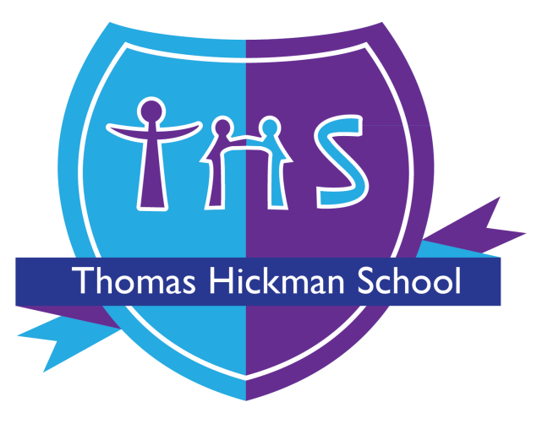

Thomas Hickman School
Response to Biting Policy

Adopted by Thomas Hickman School May 2021

Date of review: October 2025
Date of next review: October 2026

RESPONSE TO BITING IN EYFS POLICY

For adults, biting may seem like one of the worst things a person can do to hurt someone, however biting is a common behaviour in young children which is not often due to a child deliberately attempting to cause pain.

Biting is a common behaviour that some young children go through. This is part of some children’s development and can be triggered when they do not yet have the words to communicate their anger, frustration or need. Due to the number of children within the setting, biting in toddlers or young children is more likely to happen at Nursery, Pre-school or School than at home, where there are fewer children sharing the same toy. At Thomas Hickman School we follow our positive behaviour policy to promote positive behaviour at all times.

Causes of biting | Response to incident
Teething | Provide teething toys
Developing independence – wanting to do things themselves may result in biting when challenged. | Support by allowing children to make choices within appropriate boundaries.
Language and Communication – when children cannot talk or are limited in their speech they may bite out of frustration of not being understood. | Targeted support to develop language skills, encourage Makaton actions alongside speech. Individual/small group activities that encourage children to make sounds to ask for what they want.
Frustration/Seeking attention – the child may struggle with being overstimulated in the setting or peers not responding to them. | Support with visual timetable, adult direction to model appropriate responses.
Lack of impulse control - toddlers are limited in their ability to evaluate the consequences of their actions. | Social story so children are aware of appropriate actions and how others can use actions and words to show their peers what to do.
Anxiety – biting may be a response to stress they feel in the world around them. | Speak to parents, have there been any changes at home? Allow a quiet space, encourage keyperson attachment within setting.

Strategies to prevent biting include; sensory activities, biting rings, adequate resources and a stimulating exciting environment. However in the event of a child being bitten the following procedure will be followed:

The child who has been bitten will be comforted and checked for any visual injury. First aid will be administrated where necessary. The incident will be recorded and parents informed. The bitten area will be continued to be observed for signs of infection. For confidentiality purposes and possible conflict the name of the child who has bitten will not be disclosed to the parents.

The child who has caused the bite will be told in terms that they understand that biting (the behaviour and not the child) is unkind, and be shown that it makes staff and the child who has been bitten sad. The child will be asked to say sorry if developmentally appropriate or show they are sorry, e.g. through hugging, drawing a picture.

If a child continues to bite, observations will be carried out to try to distinguish a cause, e.g. tiredness or frustration. Meetings will be held with the child’s parents to develop strategies to prevent the biting behaviour. Parents will be reassured that it is part of a child’s development and not made to feel that it is their fault.

In the event of a bite breaking the skin and to reduce the risk of infection from bacteria, prompt treatment may be needed for both the ‘biter’ and the ‘bitten’.

If a child or member of staff sustains a bite wound where the skin has been severely broken they may require urgent medical attention after initial first aid has been carried out.

Where a child may repeatedly bite and/or if they have a particular special educational need or disability that lends itself to increased biting, e.g. in some cases of autism where a child doesn’t have the communication skills, the setting will carry out a risk assessment and may recommend immunisation with hepatitis B vaccine for all staff and children.

Resources to support:


